 | MINISTRY OF EDUCATION AND TRAINING

FPT UNIVERSITY
Capstone Project Document
Using AI for Intelligent Stock Trading

GSP25AI12
Group Members | Nguyễn Việt Anh-Leader-SE170371  Hoàng Văn Bắc-Member-SE150427  Hoàng Xuân Cảnh-Member-SE170064
Supervisor | Trần Trọng Huỳnh
Capstone Project code | SP25AI37

- Hồ Chí Minh, 4-2025 -

Table of Contents
Table of Contents 2
Acknowledgment 7
Definition and Abbreviations 7
List of Tables 9
List of Figures 11
List of Resources 12
I. ​​Project Introduction 15
1. Overview 15
1.1 Project Information 15
1.2 Project Overview 16
Project Objectives: 17
Report Structure: 17
2. Project Background 19
3. Project Objective 20
4. Problem Statement 21
5. Significance of the Project 22
6. Project Scope & Limitations 23
Scope: 23
Limitations: 23
II. Project Management Plan 24
1. Teamwork 24
1.1 Group structure and roles 24
1.2 Communication plan at work 25
2. Project management methods 25
2.1 WBS: Work Breakdown Structure 25
2.2 Risk Management 27
2.3 Quality Management 28
2.4 Budget and funding 29
2.5 Change management process 29
2.6 Conclusion and review 30
III. Existing Systems/State of the Art 30
1. Overview of the Field 30
2. Historical Context 31
3. Key Studies and Theories 31
4. Technological Advancements 32
5. Comparison of Existing Systems 33
6. Gaps in the Literature/Technology 33
7. Justification for the Project 34
IV. Methodology 34
A. Research Questions and Objectives Based on Collected Data 36
1. Research Questions and Objectives 36
2. Data Collection and Preprocessing 37
2.1. Collection 38
2.1.1. Stock Trading Data from SSI 38
2.1.2. Macroeconomic Factor Data from Global Factor Data 39
2.2. Data Processing 41
2.2.1. Data Processing Workflow for Up/Down Trend Prediction 41
2.2.2 Data for the Financial Bubble Detection Task 43
3. Preliminary Evaluation using Logistic Regression 47
3.1. Bubble Price Prediction (BB) 47
3.2. Up/Down Trend Prediction (UD) 48
3.3. Multi-Factor Portfolio Risk Assessment 48
4. Propose solution 49
B. Module design 51
1. Select features and techniques for Program 1 51
1.1 Data preparation 51
1.1.1. Load data 52
1.1.2 Feature Preparation 52
1.1.2.1. Missing value imputation 52
1.1.2.2. Label shift 53
1.1.3. Feature Selection 53
1.1.3.1. Outlier Clipping 53
1.1.3.2. Feature importance 54
1.1.4. Data Splitting 55
1.1.4.1. Split training, validation, testing files by timeline 55
1.1.4.2. Time Window Transformation 56
1.1.5 Feature Scaling And Augmentation 57
1.1.5.1. Standardization 57
1.1.5.2 SMOTE (Synthetic Minority Over-sampling Technique) 57
1.2. Model 58
1.2.1. Logistic Regression Model 58
1.2.1.1. Input 58
1.2.1.2. Hypothesis Function: 58
1.2.1.3. Cost Function 59
1.2.1.4. Optimization with L2 Regularization: 59
1.2.1.4. In scikit-learn: 60
1.2.2. SVM Model 61
1.2.2.1. Input 61
1.2.2.2. Hypothesis Function 61
1.2.2.3. Cost Function (Objective with Soft Margin and L2 Regularization) 62
1.2.2.4. Kernel Trick (for Non-linear Separation) 62
1.2.2.5. In scikit-learn: 63
1.2.3. LSTM Model 63
1.2.3.1. Input 63
1.2.3.2. LSTMCell: 64
1.2.3.3. Forward Pass 66
1.2.4. Transformer Model 68
1.2.4.1. Input projection: 69
1.2.4.2. Learnable Positional Encoding: 70
1.2.4.2. Learnable version: 70
1.2.4.3. Transformer Encoder Layer 71
1.2.4.3.1. Multi-Head Self-Attention 71
1.2.4.3. Feed forward 72
1.2.4.4. Forward Pass 72
2. Model training, validation, Testing and inference. 74
2.1. Optimizer 74
2.1.1. Check class Distribution 75
2.1.2. Logistic Regression and SVM 75
2.1.2.1. Setup parameter ranges 75
2.1.2.2. Random-Search 77
2.1.3. LSTM and Transformer: 77
2.1.3.1. Setup parameter ranges 77
2.1.3.2. Op-Tuna 78
2.1.4. Train the LSTM, Transformer model 79
2.2. Trainer 80
2.3 Predictor. 82
2.4 Inferencer 84
2.4.1 Inference. 84
2.4.2 Push Data to MongoDB. 86
3. Evaluation metrics 88
3.1. Evaluate Metrics: 88
3.1.1. Accuracy: 88
3.1.2. Precision 88
3.1.3. Recall 88
3.1.4. F1-score 89
3.2. Detailed results evaluation 89
BB Statistics Description: 89
UD Statistics Description: 91
About each model: 93
4. Implementation plan 95
4.1. Explanation for Choosing the Appropriate Deployment Method. 95
4.2. Deploy: to AWS 96
4.2.1. Docker Image. 98
4.2.2. Get mongo data 99
4.2.3. API 101
5.Ethical Considerations 102
5.1. Data Privacy and Security 102
5.2. Model Accuracy and Transparency 103
5.3. Fairness and Non-Discrimination 103
5.4. Market Impact and Social Responsibility 103
5.5. Continuous Monitoring and Improvement 103
5.6. Abuse Prevention and Manipulation Control 104
C. Multi-Factor Model for Portfolio Return Explanation and Prediction 104
1. Feature and Technique Selection 104
2. Model Training and Validation 107
3. Evaluation Metrics 108
4. Implementation Details 109
5. Ethical and Safety Considerations 110
V. System Design and Implementation (Web) 112
A. System Architecture and Operational Flow 112
1. System Architecture Overview 112
2. Detailed Description 113
2.1 Data Flow and Model Inference 113
2.2 Frontend and Backend Integration Flow 115
3. Technologies Used 120
4. Key Features 120
B. Intelligent Web Platform for Financial Investment Support 121
1. AI Model Integration 121
2. Data Flow and Processing 122
VI. Results and Discussion 124
1. Results and Analysis 124
2. Discussion 126
3. Recommendations 127
4. Personal Reflections 128
VII. Conclusion 128
1. Summary of Results 128
2. Contributions and Project Reflections 129
3. Limitations and Future Work 129
VIII. Refereences 130

Acknowledgment
We would like to extend our deepest gratitude to our academic supervisor, Mr. Trần Trọng Huỳnh, for his invaluable guidance, constructive feedback, and unwavering support throughout the course of this project.
We are also thankful to the faculty of FPT University for providing us with a solid academic foundation.
Our heartfelt thanks also go to our families and friends for their encouragement and continuous support, which have been instrumental in our success.

Definition and Abbreviations
Abbreviation | Definition
AI | Artificial Intelligence
DL | Deep Learning
ML | Machine Learning
PMP | Project Manager Plan
WBS | Work Breakdown Structure
ATR | Average True Range
BB | This is a stock bubble prediction problem.
UD | This is a stock up or down prediction problem.
LR | Logistic Regression – A logistic regression model used for binary classification.
SVM | Support Vector Machine – A Model used for binary classification.
LSTM | Long Short-Term Memory model.
TFM | Transformer model.
HL | High-Low
LO | Low-Open
SR | Support Resistance
PM | Price Momentum
MDD | Maximum Drawdown
TVV | Trading Volume Volatility
SK | Skewness
MA7_t, MA14_t, MA21_t | 7-day, 14-day, 21-day Moving Averages
SMOTE | Synthetic Minority Over-sampling Technique
CAPM | Capital Asset Pricing Model
Fama-French 3 Factors | Fama-French 3-Factor Model
Carhart 4 Factors | Carhart 4-Factor Model
RMW | Robust Minus Weak Factor
CMA | Conservative Minus Aggressive Facto
MOM | Momentum Factor
HML | High Minus Low Factor
SMB | Small Minus Big Factor
ADF | Augmented Dickey-Fuller Test
API | Application Programming Interface
EC2 | Elastic Compute Cloud
ECR | Elastic Container Registry
AWS | Amazon Web Services
ROC | Receiver Operating Characteristic Curve
CSV | Comma-Separated Values
F1-Score | Harmonic Mean of Precision and Recall
MAE | Mean Absolute Error
R-squared | Coefficient of Determination
RMSE | Root Mean Square Error
Alpha | Measure of Portfolio’s Excess Return
Beta | Measure of Systematic Risk Relative to Market

List of Tables
Table I.1.1.Project Team Members.
Table II.1.1: Group structure and roles.
Table II.2.1. WBS: Work Breakdown Structure
Table II.2.3: Number of working days compared
Table IV.A.2.1.1. The original daily data.
Table IV.A.2.1.2. Global Factor Data.
Table IV.A.2.2.1. Input Feature Table for the Up/Down Prediction Task
Table IV.A.2.2.2. List of Input Features for the Bubble Detection Task
Table IV.A.3. Top 5 tickers by Accuracy for BB
Table IV.B.1.1.3.2: Select feature importance.
Table IV.B.1.1.4.1: Split training, validation, testing files by timeline.
Table IV.B.1.2.1.5: Meaning of parameters in LR_PARAM_RANGES.
Table IV.B.1.2.2.5: Meaning of parameters in SVM_PARAM_RANGES.
Table IV.B.2.2.2.1: Setup parameter ranges in LR_SVM_PARAM_RANGES.
Table IV.B.2.2.3.1: Setup parameter ranges in LSTM_TFM_PARAM_RANGES.
Table IV.B.3.2.a: BB STATISTICS DESCRIPTION Train dataset.
Table IV.B.3.2.b: BB STATISTICS DESCRIPTION Valid dataset.
Table IV.B.3.2.c: BB STATISTICS DESCRIPTION Test dataset.
Table IV.B.3.2.d: UD STATISTICS DESCRIPTION Train dataset.
Table IV.B.3.2.e: UD STATISTICS DESCRIPTION Valid dataset.
Table IV.B.3.2.f: UD STATISTICS DESCRIPTION test dataset.
Table V.2: Input data API.
Table VI.1. Good model quantity review.

List of Figures
Figure IV.A.2.2.2. Distribution of Bubble Occurrence Rates (bubble_percent) by Stock Ticker (Source: Own work).
Figure IV.A.4: Using AI for Intelligent stock trading (Source: Own work).
Figure IV.B: End-to-End Pipeline: Feature Engineering Input → API Output
Figure IV.B.1.1: Data preparation.

Figure IV.B.1.2.3.2: LSTMCell.
Figure IV.B.1.2.3.3: LSTM Model.
Figure IV.B.1.2.4: Transformer layer.
Figure IV.B.1.2.4.4: Transformer Model.
Figure IV.B.2.2: Optimizer.
Figure IV.B.2.3: Trainer.
Figure IV.B.3.2.g: Average score of all models by BB, UD.
Figure IV.B.4.1: Push data to mongo DB.
Figure IV.B.4.2: Deploy: to AWS.
Figure IV.B.4.2.1: Get mongo data.
Figure IV.B.4.2.2: API. for BB, UD.
Figure IV.B.4.2.3: Form Github push ECR and run EC2.
Figure V.1 – Detailed flow of the Web Application integrating Frontend and Backend operations
Figure VI. Top Tickets by BB, UD Train, Valid, Test dataset

List of Resources
Capstone Resources
Input resources | Output resources
Using AI for Intelligent stock trading | Propose solution
Using AI for Intelligent stock trading | Propose solution
Using AI for Intelligent stock trading | Propose solution
data collection requirements | Data collection
data collection requirements | Data collection
data collection requirements | Data collection
Propose solution BB | Code BB
 | Feature engineering BB
Propose solution UD | Code UD
 | Feature engineering UD
Propose solution MF
 | On Excel MF create feature engineering MF
Feature engineering MF | Code MF
Feature engineering BB | Code BB
 | Metrix BB
Feature engineering UD | Code UD
 | Metrix UD
 | API BB_UD
API BB_UD
Code MF | Web
Reference:Project Management.xlsx

I. ​​Project Introduction
Making wise investing decisions in the face of an increasingly erratic and volatile stock market necessitates not just specific expertise but also the capacity for rapid and precise data analysis. Our capstone project's objective is to use contemporary artificial intelligence (AI) techniques to help investors make more informed stock trading decisions.
The project's main goal is to create an intelligent stock trading support system that can process financial data and offer recommendations for investments in real time. In particular, we tackle three primary issues:
- Monthly Bubble Price Prediction – identifying periods when stock prices are likely inflated relative to their intrinsic value.
- Weekly Stock Trend Prediction – supporting short-term investment decisions by forecasting upward or downward trends.
- Portfolio Risk Assessment – combining profit forecasting and risk analysis to recommend whether to buy, sell, or hold stocks.
The system is anticipated to improve users' decision-making skills by combining several prediction models and utilizing AI in large data analysis, particularly during times of abrupt market swings.

1. Overview

1.1 Project Information
- Project Title: Using AI for Intelligent Stock Trading
- Project Code: SP25AI37
- Group Code: GSP25AI12
Project Team Members:
Table I.1.1.Project Team Members.
Full Name | Student ID | Phone Number | Email | Role
Nguyễn Việt Anh | SE170371 | 0368540482 | anhnvse170371@fpt.edu.vn | Team Leader
Hoàng Xuân Cảnh | SE170064 | 0931486527 | canhhxse170064@fpt.edu.vn | Member
Hoàng Văn Bắc | SE150427 | 0971932296 | bachvse150427@fpt.edu.vn | Member
Academic Supervisor:
- Name: Trần Trọng Huỳnh
- Email: huynhtt@fpt.edu.vn
- Role: Supervisor 1
The supervisor is responsible for providing technical guidance, offering feedback on algorithms, and evaluating the project's progress at each stage.

1.2 Project Overview
In the context of rapid financial market fluctuations and the overwhelming volume of trading data, investors increasingly require tools that can assist them in making informed, timely, and data-driven decisions. This project proposes the development of an AI-powered system that addresses three critical aspects of intelligent stock trading:
(1) monthly bubble price detection,
(2) weekly stock trend forecasting, and
(3) multi-factor portfolio risk evaluation.
The goal is not simply to predict stock movements, but to integrate AI techniques with financial models in a way that enhances decision-making accuracy, manages risk, and increases transparency.

Project Objectives:
- Bubble Price Prediction (BB)
Identify potential overvaluation periods where stock prices may deviate significantly from their intrinsic values, helping investors avoid speculative bubbles.
- Up/Down Trend Forecasting (UD)
Predict short-term price direction (weekly) to assist traders in making timely buy/sell decisions.
- Portfolio Risk and Return Assessment (MF)
Apply quantitative finance models such as CAPM, Fama-French 3-factor, Carhart 4-factor, and Fama-French 5-factor to assess investment performance metrics including alpha, beta, and idiosyncratic risk.

Report Structure:
This report is structured into eight chapters, reflecting the complete development and evaluation cycle of the project:
- Chapter I – Project Introduction
Background, significance, objectives, and problem statement of the project.
- Chapter II – Project Management Plan
Team roles, working timeline, WBS, risk handling, and quality assurance.
- Chapter III – Existing Systems and State of the Art
Literature review on AI in finance and existing gaps in current systems.
- Chapter IV – Methodology
Data collection, feature engineering, model design, training, optimization, and evaluation metrics for BB, UD, and MF modules.
- Chapter V – System Design and Implementation (Web)
System architecture, integration of trained models, and deployment on AWS with API interfaces.
- Chapter VI – Results and Discussion
Model performance across tickers and tasks, and insights from the experiments.
- Chapter VII – Conclusion
Project summary, contributions, limitations, and directions for future work.
- Chapter VIII – References
Cited studies, frameworks, and technical resources used throughout the project.
By combining traditional machine learning models (Logistic Regression, SVM) and deep learning architectures (LSTM, Transformer) into a full-stack pipeline—from data processing to API deployment—the system aims to deliver actionable investment insights through an interactive web interface.

2. Project Background
In recent years, the Vietnamese stock market has witnessed a significant surge in both retail investor participation and data volume. With over 1,600 publicly listed stocks and millions of daily transactions, investors are faced with an overwhelming amount of information that changes rapidly due to various influences such as investor sentiment, political events, global trends, and money flows.
Despite the availability of traditional analysis tools—such as fundamental and technical indicators—many individual investors still struggle to process market information efficiently. Decisions are often made based on emotion, social media discussions, or personal bias, leading to poor timing in buying or selling stocks.
These challenges highlight the urgent need for intelligent systems that can automate data analysis, forecast trends, and assess portfolio risks. Artificial intelligence (AI), particularly machine learning and deep learning models, has shown strong potential in handling financial time series, detecting patterns, and modeling non-linear relationships in data.
Therefore, this project focuses on developing a comprehensive AI-based decision support system that addresses three critical tasks:
- Detecting speculative price bubbles to avoid irrational market entries,
- Forecasting weekly up/down trends for tactical decision-making,
- Evaluating portfolio risks using multi-factor financial models.
By addressing these areas, the system aims to enhance investor confidence, reduce emotional decision-making, and contribute to a more rational investing environment in Vietnam.

3. Project Objective
The objective of this project is to develop an AI-driven stock trading decision support system that can process large-scale financial data and provide timely, accurate, and interpretable investment recommendations.
The system focuses on achieving three key functions:
- Monthly Bubble Price Prediction (BB):
Detect potential stock price bubbles using time series analysis and statistical stationarity tests to help investors avoid speculative market traps.
- Weekly Up/Down Trend Forecasting (UD):
Predict the short-term price movement direction of stocks to support trading decisions at the weekly level.
- Portfolio Risk and Return Assessment (MF):
Evaluate the overall performance and risk profile of a portfolio using multi-factor financial models including CAPM, Fama-French 3-factor, Carhart 4-factor, and Fama-French 5-factor. This provides insights into alpha, beta, and systematic versus idiosyncratic risk.
These objectives are addressed through the integration of machine learning and deep learning models, enabling the system to operate across both short-term trading and long-term investment perspectives.

4. Problem Statement
In an increasingly volatile and information-saturated stock market, investors especially retail traders face significant challenges in making timely and informed decisions. Many still rely heavily on emotional impulses, crowd behavior, or social media rumors, which often leads to irrational investment actions such as buying during market peaks or panic selling.
Moreover, existing financial tools either lack predictive capabilities or require a high level of financial literacy, creating a gap between data availability and actionable insights.
This project addresses the following core problems:
- The absence of automated systems capable of predicting both short-term price movements and long-term risk.
- The lack of tools that can detect speculative price bubbles based on statistical and AI-based analysis.
- The need for integrated portfolio-level evaluation combining machine learning predictions with established financial models.
By solving these issues, the system aims to empower investors to make smarter, data-backed decisions and reduce their exposure to behavioral biases and information asymmetry.

5. Significance of the Project
This project holds both academic and practical significance:
- Academic Value:
It demonstrates how AI techniques ranging from classical ML models to deep learning can be applied to real-world financial datasets. Students gain hands-on experience in feature engineering, time series modeling, evaluation metrics, and deploying ML systems.
- Practical Value:
The system provides retail investors with a simple yet effective tool for analyzing the market. By offering predictions, alerts, and risk indicators, it improves decision-making quality without requiring deep financial expertise.
- Social Value:
By encouraging evidence-based investing and reducing reliance on informal sources (e.g., social media groups), the system contributes to building a more transparent and rational investment culture in Vietnam.

6. Project Scope & Limitations

Scope:
- Apply multiple machine learning and deep learning models (Logistic Regression, SVM, LSTM, Transformer) to two primary prediction tasks: Bubble Detection (BB) and Up/Down Trend Forecasting (UD).
- Use historical stock market data from SSI (2006–2025) and macroeconomic/global factor data from international sources (2020–2025).
- Provide a web-based interface where users can view predictions and portfolio risk metrics based on selected stock tickers.
- Evaluate the system using standard classification metrics (Accuracy, Precision, Recall, F1-score) and financial indicators (Alpha, Beta, R²).

Limitations:
- Predictions are based solely on historical data and may not account for sudden macroeconomic or geopolitical events.
- The system currently supports a selected subset of stock tickers, not the entire Vietnamese stock market.
- Real-time data ingestion and automated trading execution are not within the scope of this phase.
- Sentiment analysis, news integration, or investor psychology are not yet incorporated.

II. Project Management Plan

1. Teamwork

1.1 Group structure and roles
The project team consists of three members, each assigned with specific responsibilities to ensure balanced workload and efficient execution across all project phases.
Table II.1.1: Group structure and roles.

Full name | student ID | Role | Primary responsibilities
Nguyễn Việt Anh | SE170371 | Team Leader | Research Methodology, data processing, main report writer
Hoàng Xuân Cảnh | SE170064 | Member | Data collector, training model, Website developer, web report writer + main report supporter
Hoàng Văn Bắc | SE150427 | Member | Data collector, evaluate model, report’s evaluation part writer, main report supporter

1.2 Communication plan at work
- The team uses the following main communication channels: Zalo group, Google Meet, and Gmail. These tools facilitate daily work discussions, document sharing, and quick notifications of any arising issues.
- Meetings with the instructor are usually held once a week, typically at the weekend, after the team has updated its work progress. The purpose of the meetings is to provide updates, receive feedback from the instructor, and adjust the direction if necessary.

2. Project management methods

2.1 WBS: Work Breakdown Structure
Each content item represents a group of tasks (divided into smaller subtasks). The tasks include:
- Ideation and task assignment
- Data collection
- Methodology research
- Program module design
- Web system implementation design
- Project report writing
Each task is assigned to members with primary responsibility and includes clearly stated start/end dates, number of working days, completion percentage, and task outcomes.
Table II.2.1. WBS: Work Breakdown Structure.
ID | Tasks | Workers | Start | End | Days | % complete | Workday
1 | Make Idea and division of work tasks |  | Th 5 1/09/25 | Th 4 1/22/25 | 42 |  | 30
1.1 | Idea + work tasks | Hoàng xuân Cảnh | Th 5 1/09/25 | Th 4 1/22/25 | 14 | 100% | 10
1.2 | Idea + work tasks | Hoàng văn Bắc | Th 5 1/09/25 | Th 4 1/22/25 | 14 | 100% | 10
1.3 | Idea + work tasks | Nguyễn Việt Anh | Th 5 1/09/25 | Th 4 1/22/25 | 14 | 100% | 10
1.4
2 | Data collection |  | Th 5 1/23/25 | Th 4 2/05/25 | 42 |  | 30
2.1 | From SSI | Hoàng xuân cảnh | Th 5 1/23/25 | Th 4 2/05/25 | 14 | 100% | 10
2.2 | From Vnstock | Hoàng văn Bắc | Th 5 1/23/25 | Th 4 2/05/25 | 14 | 100% | 10
2.3 | From Global Factor Data | Nguyễn Việt Anh | Th 5 1/23/25 | Th 4 2/05/25 | 14 | 100% | 10
2.4
3 | Research methods |  | Th 5 2/06/25 | Th 4 3/26/25 | 49 |  | 35
3.1 | Feature Engineering and Label Generation for BB | Nguyễn Việt Anh | Th 5 2/06/25 | Th 2 3/03/25 | 26 | 100% | 18
3.2 | Evaluation of Feature Engineering Results for BB | Nguyễn Việt Anh | Th 3 3/04/25 | Th 7 3/08/25 | 5 | 100% | 4
3.3 | Feature Engineering and Label Generation for UD | Nguyễn Việt Anh | CN 3/09/25 | Th 2 3/17/25 | 9 | 100% | 6
3.4 | Evaluation of Feature Engineering Results for UD | Nguyễn Việt Anh | Th 3 3/18/25 | Th 7 3/22/25 | 5 | 100% | 4
3.5 | Global Factor Data | Nguyễn Việt Anh | CN 3/23/25 | Th 2 3/24/25 | 2 | 100% | 1
3.6 | Evaluation of Results under Feature Transformation | Nguyễn Việt Anh | Th 3 3/25/25 | Th 4 3/26/25 | 2 | 100% | 2
3.7
4 | Multi-Factor Model |  | Th 5 3/27/25 | Th 3 4/08/25 | 13 |  | 9
4.1 | Portfolio Return Explanation and Prediction | Nguyễn Việt Anh | Th 5 3/27/25 | Th 3 4/08/25 | 13 | 100% | 9
4.2
5 | Module 1 design |  | Th 5 2/06/25 | Th 4 4/09/25 | 63 |  | 45
5.1 | Building a program for BB | Hoàng văn Bắc | Th 5 2/06/25 | CN 3/09/25 | 32 | 100% | 22
5.2 | Evaluation of BB model construction results | Hoàng văn Bắc | Th 2 3/10/25 | Th 3 3/18/25 | 9 | 100% | 7
5.3 | Building a program for UD | Hoàng văn Bắc | Th 4 3/19/25 | Th 4 4/02/25 | 15 | 100% | 11
5.4 | Evaluation of UD model construction results | Hoàng văn Bắc | Th 5 4/03/25 | Th 4 4/09/25 | 7 | 100% | 5
5.5
6 | System design and implementation |  | Th 5 2/06/25 | Th 5 4/10/25 | 64 |  | 46
6.1 | Front -end | Hoàng xuân cảnh | Th 5 2/06/25 | Th 4 3/19/25 | 42 | 100% | 30
6.2 | Back-end | Hoàng xuân cảnh | Th 5 3/20/25 | Th 5 4/10/25 | 22 | 100% | 16
6.3
7 | Project Report |  | Th 4 4/09/25 | Th 3 4/22/25 | 25 |  | 20
7.1 | 0. Slide | Nguyễn Việt Anh | Th 4 4/09/25 | Th 4 4/09/25 | 1 | 100% | 1
7.2 | I. Project Introduction | Nguyễn Việt Anh | Th 5 4/10/25 | Th 5 4/10/25 | 1 | 100% | 1
7.3 | II. Project Management Plan | Hoàng văn Bắc | Th 5 4/10/25 | Th 5 4/10/25 | 1 | 100% | 1
7.4 | III. Existing Systems/State of the Art | Nguyễn Việt Anh | Th 6 4/11/25 | CN 4/13/25 | 3 | 100% | 1
7.5 | IV.A. Research Questions and Objectives Based on Collected Data | Nguyễn Việt Anh | Th 2 4/14/25 | Th 4 4/16/25 | 3 | 100% | 3
7.6 | IV.B. Module 1 design | Hoàng văn Bắc | Th 6 4/11/25 | Th 4 4/16/25 | 6 | 100% | 4
7.7 | 1.2.2. SVM Model | Nguyễn Việt Anh | Th 5 4/17/25 | Th 5 4/17/25 | 1 | 100% | 1
7.8 | IV.C. Multi-Factor Model for Portfolio Return Explanation and Prediction | Nguyễn Việt Anh | Th 6 4/18/25 | Th 6 4/18/25 | 1 | 100% | 1
7.9 | V. System Design and Implementation (Web) | Hoàng xuân cảnh | Th 6 4/11/25 | Th 4 4/16/25 | 6 | 100% | 4
7.10 | VI. Results and Discussion | Nguyễn Việt Anh | Th 7 4/19/25 | Th 2 4/21/25 | 3 | 100% | 1
7.11 | VII. Conclusion | Nguyễn Việt Anh | Th 3 4/22/25 | Th 3 4/22/25 | 1 | 100% | 1
Reference:Project Management.xlsx

2.2 Risk Management
Data Risks: Missing, inaccurate, or difficult-to-synchronize data.
- Solution: Identify reliable data sources, standardize and assign data responsibilities, and establish a secondary backup source.
Team Progress Desynchronization Risks:
- Solution: Hold regular team meetings and provide timely updates on progress to respond effectively to unexpected situations.
Technical Risks (e.g., bugs, tools, model non-convergence):
- Solution: Maintain detailed logs, use checkpoints by module during the optimizer and model training phases to react promptly and handle unforeseen issues.
Online Deployment Risks (deploying individual modules and the web interface):
- Solution: Check system compatibility, run tests in a staging environment before production, and prepare backups for services such as servers.
Timeline Risk Management is mapped according to the WBS, with contingency plans for each module. Extra time is allocated for each task—task durations are effectively doubled compared to the original deadlines to allow for unexpected delays.

2.3 Quality Management
Standards and Requirements:
- Code must be functional and reproducible.
- Each module must:
  - Achieve ≥ specified minimum model performance (F1-score).
  - Produce API-ready output.
  - Be documented in GitHub repo.

Monitoring Metrics:
- % Completion based on WBS: All tasks must reach 100% within allocated time.
- Workdays Monitoring: Compared to plan using Table II.2.3:
Table II.2.3: Number of working days compared.
Member | Workday
Nguyễn Việt Anh | 74
Hoàng xuân cảnh | 70
Hoàng văn Bắc | 70

2.4 Budget and funding
The project does not use any external funding. All activities are carried out using personal resources (personal computers, self-funded AWS student accounts, and free services such as Google Colab, GitHub, MongoDB, etc.).

2.5 Change management process
The project initially set out two development approaches:
- Way 1: Build the system from scratch based on the proposed design aligned with the academic requirements.
- Way 2: An expansion/upgrade plan for the future, involving the development of multiple modules that generalize market condition predictions. This may include new methods for label prediction, and the use of reinforcement learning models to simulate user behavior and recommend optimal strategies. It also envisions upgrading the web application and eventually deploying it as a mobile app.
In the current phase, the team is following Way 1, ensuring the core pipeline and main data remain intact.

2.6 Conclusion and review
Summary: All modules were completed on schedule, with functioning code, complete data, and well-performing models.The experimental results were clearly reported, with objective evaluations highlighting areas for improvement to enhance accuracy. The web application runs stably, supporting core user functionalities, though further upgrades are needed to improve user experience.
Lessons Learned:
- Roles and responsibilities should be clearly defined from the beginning.
- Time estimation for each task needs to be more accurate.
- Teamwork skills, resource sharing, and troubleshooting should be further improved.

III. Existing Systems/State of the Art

1. Overview of the Field
Artificial Intelligence (AI) has become a transformative force in the financial sector, especially in stock trading. The ability of AI to process massive volumes of data, detect complex patterns, and make probabilistic forecasts surpasses the limitations of traditional technical analysis and rule-based strategies. In recent years, AI has been widely applied in algorithmic trading, risk modeling, and sentiment analysis. This trend reflects an increasing demand for intelligent systems that can support decision-making in fast-moving and volatile markets.
Our project leverages this trend by combining machine learning (ML), deep learning (DL), and financial modeling to build a practical, AI-driven stock trading support system tailored to the Vietnamese market.

2. Historical Context
The use of algorithmic strategies in finance began to surge in the early 2000s, with firms like Renaissance Technologies and Two Sigma pioneering the integration of statistical learning and high-frequency trading. During the 2010s, the evolution of deep learning opened new frontiers in time series analysis. Models such as Long Short-Term Memory (LSTM) networks and Transformer architectures enabled the modeling of nonlinear relationships and long-range dependencies in sequential financial data.
Meanwhile, the theoretical foundations of portfolio evaluation were built much earlier. Key models such as the Capital Asset Pricing Model (CAPM – 1964), Fama-French 3-Factor Model (1993), and Carhart 4-Factor Model (1997) remain widely used for quantifying systemic risk, return drivers, and investment performance. These traditional models still provide the basis for rigorous portfolio assessment today.

3. Key Studies and Theories
The Fama-French 3 Factors model, which expands on the CAPM by including size and value factors, the Carhart 4 Factors model, which adds a momentum factor to further explain stock returns, and Sharpe's CAPM model, which demonstrates the connection between systematic risk and an asset's expected return, are foundational studies in this field.
Fischer and Krauss (2018) showed that LSTM is the most effective machine learning technique for stock market forecasting. A new age was also brought about by the groundbreaking study "Attention is All You Need" (Vaswani et al., 2017), which introduced the Transformer model, which made it possible to model complicated financial time series data in an effective and adaptable manner.

4. Technological Advancements
Several technological advancements underpin this project:
- Modeling Techniques:
  - Deep learning models like LSTM and Transformer enable high-capacity modeling of temporal financial data with complex dependencies.
  - SMOTE (Synthetic Minority Oversampling Technique) addresses class imbalance in binary classification tasks such as bubble detection or trend direction.
- Optimization Frameworks:
  - Random Search and Optuna allow for efficient hyperparameter tuning, enhancing model performance without exhaustive grid search.
- Model Deployment Infrastructure:
  - FastAPI enables real-time RESTful API services.
  - MongoDB serves as a flexible NoSQL database for storing prediction results and user queries.
  - AWS services (EC2, ECR) provide scalable cloud hosting for production deployment.
These advancements ensure that the system is not only intelligent but also deployable, robust, and scalable.

5. Comparison of Existing Systems
Popular platforms such as TradingView or QuantConnect offer technical indicators and strategy testing environments. However, they typically rely on basic models like moving averages, RSI, or backtesting rules, without deep learning capabilities or risk-adjusted portfolio analysis.
In contrast, our proposed system introduces key differentiators:
- Combines short-term trend prediction and long-term bubble detection.
- Incorporates multi-factor risk models grounded in academic finance theory.
- Provides real-time, explainable results through web APIs.
- Focuses specifically on Vietnamese stock data—a market often overlooked by global platforms.
This makes our system more holistic and practical, especially for retail investors seeking both tactical insights and portfolio-level evaluations.

6. Gaps in the Literature/Technology
Despite the progress in AI-driven trading systems, several critical gaps remain:
- Most systems focus only on price direction or next-day movement, ignoring valuation bubbles that can lead to overconfident entries.
- Many black-box models provide predictions without performance attribution, making it difficult for users to understand or trust the output.
- Portfolio-level risk modeling is rarely integrated with AI forecasts, leaving users without a comprehensive view of risk-return trade-offs.
Our system addresses these gaps by incorporating financial evaluation metrics (e.g., alpha, beta, Sharpe ratio) into the output and using interpretable ML/DL models for prediction tasks.

7. Justification for the Project
The proposed system is innovative in its integration of modern AI techniques and traditional financial evaluation models. It leverages deep learning (LSTM, Transformer) to forecast complex stock behaviors while validating predictions through robust multi-factor models.
Furthermore, the project is built with real-world deployment in mind, using scalable web technologies and a modular architecture. With a focus on the Vietnamese market, this system provides a unique and practical solution that can be extended to other emerging markets. It not only contributes academically but also has the potential to evolve into a functional FinTech product for investment education and decision-making.

IV. Methodology
This research introduces a system designed to aid investment decisions by synergizing advanced machine learning techniques with established quantitative financial models. The deployment follows an end-to-end pipeline encompassing data acquisition, processing and normalization, feature engineering, model training, and the delivery of forecasting results via an API.
Information is sourced from two key origins. The primary source is the SSI trading platform, providing a historical dataset of trading activity from January 1, 2006, to the present day for 1631 publicly traded stocks in Vietnam. This dataset includes stock tickers, transaction dates, opening, peak, trough, and closing prices, alongside trading volumes, aggregated across daily, weekly, and monthly intervals. The secondary source is Global Factor Data, spanning from January 2020 to the current month, featuring monthly financial factors such as market excess return (mkt), risk-free rate (rf), investment patterns (inv), profitability metrics (profit), momentum indicators (mom), value characteristics, and company size (size), intended for the long-horizon quantitative model.
Upon collection, the raw data undergoes processing to handle missing entries, smooth temporal sequences, and compute relevant technical indicators like investment returns (ret), price volatility, maximum drawdown (MDD), the Relative Strength Index (RSI), 7/14/21-day moving averages (MA), rolling standard deviation, and adjusted logarithmic prices. Furthermore, we employ the GSADF test, implemented through a rolling window ADF test on adjusted log prices, to identify potential price bubbles.
The central problem is decomposed into two core tasks: predicting financial bubble occurrences (BB) and forecasting upward or downward stock price movements (UD). For each of these tasks, we utilize two distinct categories of models. The conventional model set comprises Logistic Regression (LR) and Support Vector Machine (SVM), operating on structured 2D data, producing binary classification outcomes. The time-series model set includes Long Short-Term Memory (LSTM) networks and Transformer architectures, processing 3D sequential data, outputting binary prediction probabilities.
Concurrently, to assess the performance and risk associated with long-term investment portfolios, this study applies established quantitative finance models, namely the Capital Asset Pricing Model (CAPM), the Fama-French 3-factor model, the Carhart 4-factor model, and the Fama-French 5-factor ¹ model. These models serve to validate the reasonableness of the portfolio following predictions and to provide a quantitative lens for enhancing the quality of investment decisions

A. Research Questions and Objectives Based on Collected Data

1. Research Questions and Objectives
This study seeks to develop a sophisticated investment decision support framework by integrating cutting-edge machine learning techniques with established quantitative finance models. The implementation follows a complete pipeline, encompassing data acquisition, processing and standardization, feature generation, model training, and the delivery of predictive insights via an API.
In response to increasingly turbulent financial markets characterized by numerous non-linear influences, the application of machine learning in financial forecasting has emerged as a critical area of research. This work aims to construct an intelligent system for investment prediction and evaluation, blending technical data, market information, and quantitative financial models to empower investors in making more informed choices.
Specifically, this research pursues three primary goals:
(1) To forecast whether stock prices will rise or fall in the upcoming week (Up/Down prediction), enabling investors to proactively manage short-term strategies.
(2) To identify instances of price bubbles at an early stage, with the aim of mitigating risks associated with unsustainable market surges and potential sharp corrections.
(3) To assess the effectiveness of investments and the level of portfolio risk using multi-factor models such as CAPM, Fama-French 3-factor, Carhart 4-factor, and Fama-French 5-factor, thereby providing a quantitative and practical validation of the system's predictive accuracy.
Stemming from these objectives, the research team formulates the following specific inquiries:
(1) Do advanced machine learning models (like LSTM and Transformer networks) offer superior predictive accuracy in forecasting market trends compared to conventional models such as logistic regression?
(2) Does the integration of technical data, macroeconomic indicators, and time series validation outcomes enhance the capability to detect price bubbles relative to approaches relying on isolated factors?
(3) Can the investment performance of a portfolio constructed based on machine learning model predictions be clearly substantiated through quantitative metrics like alpha (excess return) and beta (risk exposure) derived from multi-factor models?

2. Data Collection and Preprocessing
Input data is the core component in building financial market forecasting models. In this research, data is collected from two main sources: the SSI securities trading platform and the Global Factor Data system. The collection process is systematic, ensuring comprehensive market coverage and the historical depth necessary for machine learning and quantitative finance models.

2.1. Collection

2.1.1. Stock Trading Data from SSI
The first data source is collected from the SSI trading platform (https://www.ssi.com.vn/), through a combination of API crawling and libraries that support communication with market data. The data includes historical trading information for 1631 stock codes listed on the Vietnamese stock market, with a time span from January 1, 2006, to April 11, 2025. The data is initially retrieved on a daily basis and then processed to create weekly and monthly datasets, serving different prediction objectives (short-term, medium-term).
Table IV.A.2.1.1. The original daily data.
Variable Name | Description | Data Type
Ticker | Stock code | string
Date | Trading date | datetime
Open | Opening price | float
High | Highest price | float
Low | Lowest price | float
Close | Closing price | float
Volume | Trading volume | int
Starting from the original daily stock data, we used the Pandas library in Python to resample the time series to levels appropriate for each specific task, including weekly and monthly frequencies. This conversion resulted in two new datasets: stock_weekly_data and stock_monthly_data, aggregated as follows:
- The Ticker remains unchanged.
- The Date is set to the first day of the corresponding week or month.
- Open is taken as the opening price of the first trading session in the period.
- High is the highest price recorded during the entire week/month.
- Low is the lowest price recorded.
- Close is the closing price of the last trading session.
- Volume is the total trading volume over the entire period.
This aggregation serves two clear objectives in the study.
Weekly data is used for the Up/Down trend prediction task, where short-term fluctuations are the focus.
Conversely, monthly data is used for the Bubble Detection task, which requires a longer-term and more stable perspective to identify abnormal deviations between stock prices and their intrinsic values.
This data processing approach ensures the consistency of the time series and the reliability of technical indicators used as input features for the machine learning models.

2.1.2. Macroeconomic Factor Data from Global Factor Data
The second data source is Global Factor Data (Jensen et al., 2023), which is used to construct multi-factor financial quantitative models, serving the goal of evaluating portfolio performance and risk at a macro level. The data was collected from sources such as the Ken French Data Library, FRED, and several other financial data systems, aggregated through an internal data repository.
The collection period for the Global Factor Data spans from January 2020 to April 2025, with a monthly frequency. The dataset, named global_factor_data, includes the following variables:
Table IV.A.2.1.2. Global Factor Data.
Variable Name | Mô tả
Data | Month - Year
Mkt | Market return
Rf | Risk-free rate
SMB | Size factor (Small Minus Big)
HML | Value factor (High Minus Low)
MOM | Momentum factor
RMW | Profitability factor (Robust Minus Weak)
CMA | Investment factor (Conservative Minus Aggressive)
These variables are used to support portfolio valuation models such as CAPM, Fama-French 3-Factor, Carhart 4-Factor , and Fama-French 5-Factor, thereby enabling the evaluation of alpha and beta metrics for portfolios generated from the machine learning model's predictions (Carhart, 1997; Fama & French, 1993, 2015; Sharpe, 1964).
All collected and processed data is stored in standard CSV format, using commas (,) as delimiters, UTF-8 encoding, and saved within the internal system to serve subsequent preprocessing and model training steps.

2.2. Data Processing

2.2.1. Data Processing Workflow for Up/Down Trend Prediction
The original daily data was aggregated into weekly cycles to enable the model to better capture short-term market fluctuations. Only stocks with continuous data from January 6, 2013, to April 13, 2025 — corresponding to over 12 years of data — were retained.
The aggregation process involved standardizing:
- Opening prices at the beginning of the week,
- Closing prices at the end of the week,
- Highest and lowest prices during the week,
- Total weekly trading volume.
From the standardized dataset, the research team extracted important technical features to serve as input for machine learning models, including:
- Weekly returns (ret),
- Volatility,
- Price fluctuation indicators (HL, LO, SR, PM),
- Maximum Drawdown (MDD),
- Average True Range (ATR) for measuring true volatility.
Additionally, the team calculated:
- TVV (standard deviation of volume),
- SK (skewness of distribution),
- Median_HL,
- Moving averages (ma7_t, ma14_t, ma21_t) to describe trend behaviors.
The feature insec_t was computed as the ratio of trading volume to price range, representing adjusted liquidity. Furthermore, the VNIndex movement was incorporated through the feature vnipc_t, reflecting broader market fluctuations.
The full list of extracted features is presented in Table IV.A.2.2.1.
The target label was assigned based on the return of the following week (fore_di_rt):
- If ≥ 0, the label is 1 (Up);
- If < 0, the label is 0 (Down).
Table IV.A.2.2.1. Input Feature Table for the Up/Down Prediction Task.
Feature | Description | Formula
ret | Return
Volatility | Rolling Std of Return (5 weeks) | 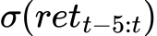
HL | High - Low | 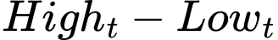
LO | Low - Open
SR | Close - Open
PM | Price Midpoint | 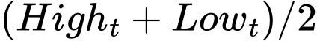
MDD | Max Drawdown
TVW | Volume Std (5 weeks) | 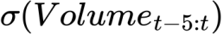
ATR | Average True Range | 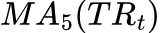
SK | Skewness (5 weeks) | 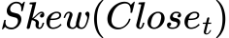
Median_HL | Median High-Low | 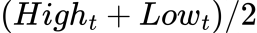
variation_t | Price Variation | 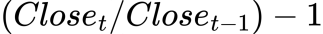
ma7_t | 7-week MA | 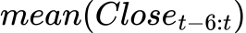
ma14_t | 14-week MA | 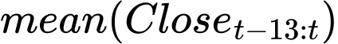
ma21_t | 21-week MA | 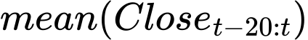
s_d7_t | Std of Close (7 weeks) | 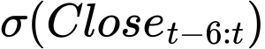
insec_t | Volume per Range
vnipc_t | VNINDEX Return

2.2.2 Data for the Financial Bubble Detection Task
A bubble happens when the price of a stock rises much higher than its real value.It often comes from excitement, rumors, or too much optimism from investors. To detect bubbles, we check if the price keeps going up too much compared to its true worth over time (Chen et al., 2021).
For the bubble price detection task, data is aggregated on a monthly basis to ensure greater stability, making it suitable for statistical testing techniques. Only stocks with continuous time series data from January 2013 to April 2025 were retained. The processed dataset includes monthly fields for opening price, closing price, highest price, lowest price, and trading volume.
After standardization, features were calculated similarly to those for the Up/Down prediction task, including:
- ret (return),
- Volatility,
- HL, LO, SR, PM (price fluctuation indicators),
- MDD (maximum drawdown),
- TVV (volume volatility),
- ATR (average true range),
- SK (skewness),
- Median_HL,
- Moving averages and volatility indicators such as s_d7_t and variation_t.
Additionally, log_price (the logarithm of the closing price) and RET (excess return) were included to support time series stationarity tests.
The full list of features is detailed in Table IV.A.2.2.2.
Table IV.A.2.2.2. List of Input Features for the Bubble Detection Task.
Feature | Description | Formula
ret | Return
Volatility | Rolling Std of Return (3 months) | 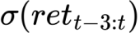
HL | High - Low | 
LO | Low - Open
SR | Close - Open
PM | Price Midpoint | 
MDD | Max Drawdown
TVW | Volume Std (3 months) | 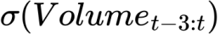
ATR | Average True Range | 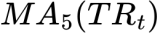
SK | Skewness (5 months) | 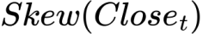
Median_HL | Median High-Low | 
fore_di_rt | Forward Return | 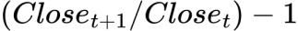
variation_t | Price Variation | 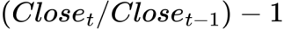
ma7_t | 7-month MA | 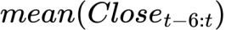
ma14_t | 14-month MA | 
ma21_t | 21-month MA | 
s_d7_t | Std of Close (7 months) | 
log_price | Log Price | 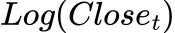
RET | Excess Return

To assign labels, the team applied the ADF test (Augmented Dickey-Fuller test) on the log_price series using a sliding window of 20 months.
If a window segment had a p-value < 0.05 and ADF-statistic < -2.9, the corresponding point was labeled with is_bubble = 1.
The bubble occurrence rate (bubble_percent) for each stock was calculated to support further analysis.
The overall average bubble rate was 47.6%, indicating a relatively high prevalence of bubble phenomena in the research dataset.
The distribution of bubble occurrence rates by stock ticker is shown in Figure IV.A.2.2.2.

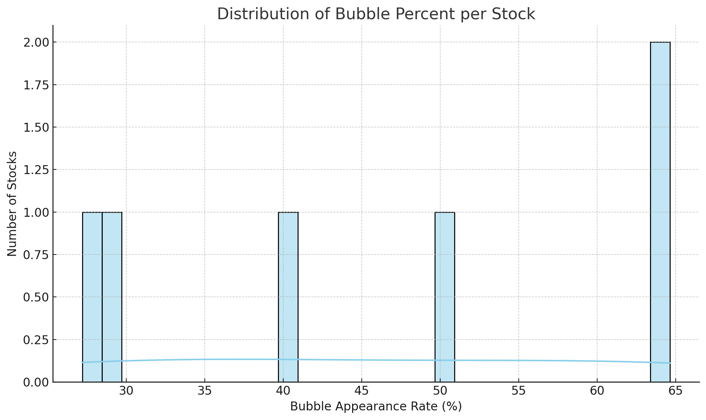
Figure IV.A.2.2.2. Distribution of Bubble Occurrence Rates (bubble_percent) by Stock Ticker (Source: Own work).

3. Preliminary Evaluation using Logistic Regression
In the initial phase of this study, a basic Logistic Regression (Logit) model was employed to assess the feasibility of applying machine learning methods to three key tasks: Bubble Detection (BB), Up/Down Prediction (UD), and Multi-Factor Risk Analysis (MF). This served as a proof-of-concept to determine whether meaningful signals could be extracted from historical price data using minimal preprocessing and simple models.

3.1. Bubble Price Prediction (BB)
For the task of Bubble Price Detection, the Logit model demonstrated encouraging results.
The Top 5 stock tickers ranked by accuracy and corresponding F1-scores are summarized in the following table:
Table IV.A.3. Top 5 tickers by Accuracy for BB.
Ticker | Accuracy (%) | F1-score
AMC | 90.00 | 0.9333
ABI | 86.67 | 0.6667
ACC | 86.67 | 0.7143
ADP | 83.33 | 0.7619
AGF | 83.33 | 0.8
These results indicate that even with a basic model and minimal feature engineering, the system is capable of achieving relatively high predictive performance for certain stocks. This reinforces the hypothesis that stock price bubbles can be identified based on appropriately engineered features extracted from historical data.

3.2. Up/Down Trend Prediction (UD)
In addition to bubble detection, the Up/Down trend prediction task (UD) also exhibits potential for model-based forecasting (Khoa & Huynh, 2021). Although preliminary experiments were not extensively detailed at this stage, the underlying analysis suggests that integrating more sophisticated models (such as LSTM and Transformer) would likely improve prediction performance, especially for capturing complex short-term stock movements.
Thus, building upon the initial insights, it is proposed to establish a dedicated module specifically for the UD prediction task, leveraging deep learning models and optimized data pipelines.

3.3. Multi-Factor Portfolio Risk Assessment
Beyond short-term forecasting, it is imperative to recognize that investment decisions require a comprehensive understanding of risk. Accordingly, the project also proposes the construction of a multi-factor portfolio evaluation framework using established financial models such as CAPM, Fama-French 3-Factor, and Carhart 4-Factor models.
Through this approach, key indicators such as Alpha (excess return), Beta (systematic risk), and R-squared (model fit) will be quantified for each portfolio derived from machine learning predictions. This integration ensures that the investment recommendations are not only data-driven but also grounded in rigorous financial risk analysis, providing investors with greater confidence and transparency in their decision-making process (Douagi et al., 2021).

4. Propose solution
To address the challenges in stock trading support, this project proposes a modular AI-based pipeline capable of executing three key tasks: short-term trend prediction, bubble price detection, and portfolio risk assessment. The overall architecture is illustrated in Figure IV.A.4.
The system begins with raw financial data, which is processed through a feature engineering pipeline. This includes technical indicator generation, label construction, and sequence transformation for time-series modeling.
The engineered data is used to train and evaluate models for:
- Up/Down Trend Prediction (UD): Forecasting weekly directional movement using both traditional (e.g., Logistic Regression, SVM) and deep learning models (LSTM, Transformer).
- Bubble Price Detection (BB): Identifying signs of speculative price bubbles using stationarity testing and classification models.
After model training, inference is performed offline on the most recent data. The predicted results for the next trading period are exported as csv files, which are then uploaded to an AWS-hosted environment.
In parallel, a Portfolio Risk Evaluation module analyzes the AI-generated returns using well-established financial models (CAPM, Fama-French 3-Factor, Carhart 4-Factor, Fama-French 5-Factor) to quantify systematic risk, alpha, and beta.
Finally, all predictions and evaluations are made available through a web-based demo interface, allowing users to view insights and performance metrics for selected stock tickers.
This modular, offline-first design provides flexibility, maintainability, and practical deployment readiness, especially for batch-based financial analysis systems.

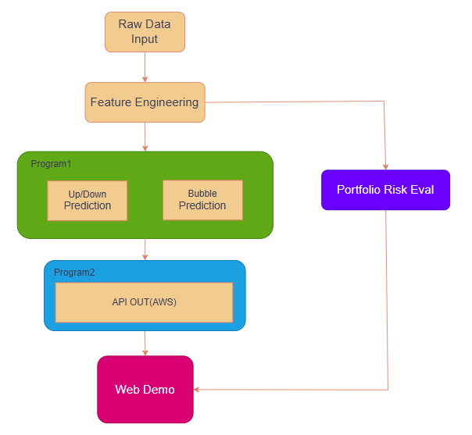
Figure IV.A.4: Using AI for Intelligent stock trading (Source: Own work).

B. Module design
The module is designed to include Program 1(It is a program for BB by month and UD by week; the program has a workflow like the one shown in Figure IV.B.) which runs independently to perform optimization, followed by training to ensure security. It then generates a file predicting the market condition. The results are subsequently pushed to MongoDB. Based on real-time data stored in MongoDB, Program 2 retrieves the data and provides an API (FastAPI) hosted on AWS at Figure IV.II.
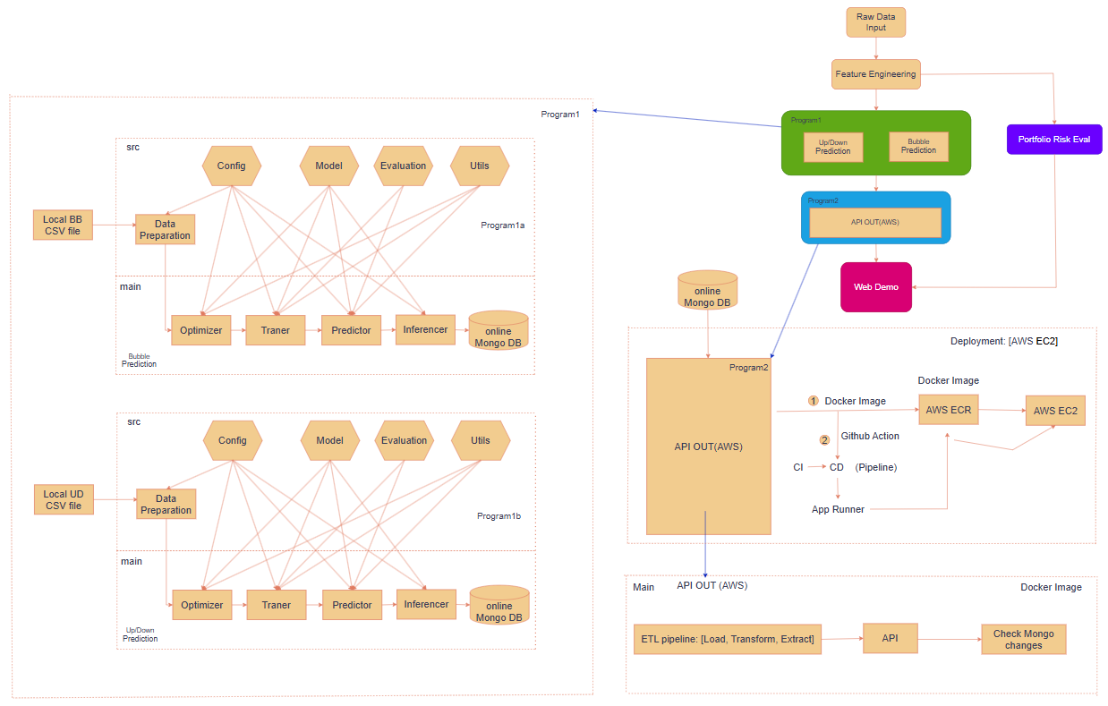
Figure IV.B: End-to-End Pipeline: Feature Engineering Input → API Output

1. Select features and techniques for Program 1

1.1 Data preparation
The process of transforming and processing input data is tailored to be compatible with all four models and to improve accuracy. This ensures fair evaluation through the following methods: Data Loading, Feature Preparation, Feature Selection, and Data Splitting at Figure IV.II.1.1.
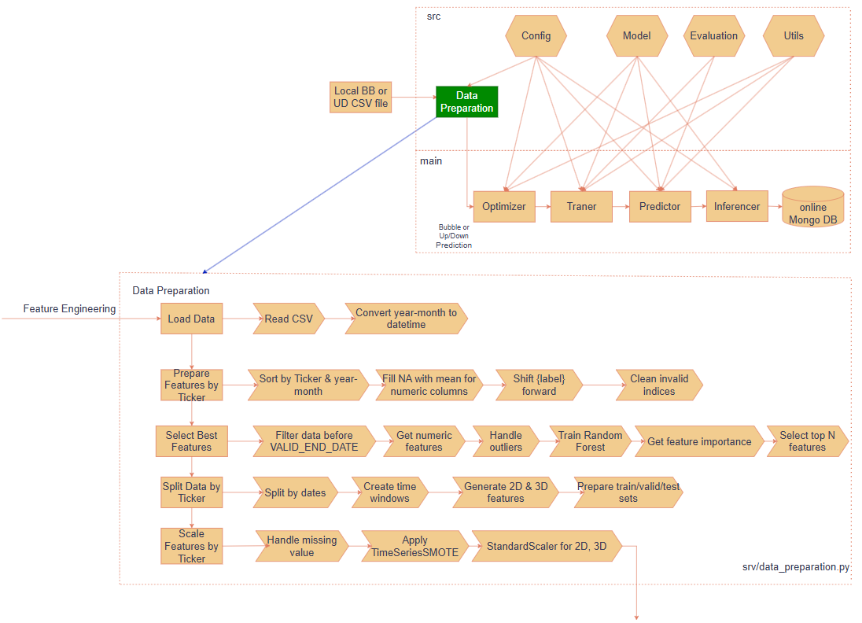
Figure IV.B.1.1: Data preparation (Source: Own work).

1.1.1. Load data
Convert ‘Month-Year’, ‘Date’ format to date-time:
Formula:
Purpose: convert standard feature to format date-time.

1.1.2 Feature Preparation

1.1.2.1. Missing value imputation
For each “” feature , missing values are replaced with the mean value of that feature:
Formula:
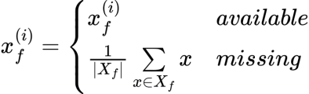
Where:
- represents the set of non-missing values of the “” feature.
- 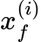is the value of the “” feature at “” sample.
Purpose: To prevent input features from having corrupted or incomplete data.

1.1.2.2. Label shift
Labels are assigned to time point based on the “Bubble (BB)” or “Up or Down (UD)” status at time point. After shifting the label by one row, we assign the label value '0' to the data row with the most recent date.
Formula:
BB:
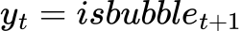
UD:
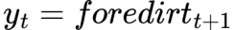
Purpose: To create data that allows prediction one week in advance for “Up or Down” labels, and one month in advance for “Bubble” labels.

1.1.3. Feature Selection

1.1.3.1. Outlier Clipping
For each “” feature, the values are limited to the range:
Formula:
Where:
- “”: are the mean and standard deviation of “” feature for each Ticker, respectively.
Purpose: To cover approximately 99.99994% of the data values and eliminate outliers or abnormal computations.

1.1.3.2. Feature importance
The ”” feature importance is calculated through a Random Forest using the training set:

Formula:

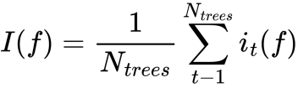
Where:
- is the total number of decision trees in the Random Forest model (n_estimators=100).
- : is the contribution of “” feature in “” tree at “”data point.
-Select a subset of important “” features with top feature to avoid using too many features when there are fewer data rows.

Table IV.B.1.1.3.2: Feature importance.

BB | UD
=10 | = 15

Purpose: To ensure better convergence during training, avoid irrelevant features that may cause noise, and reduce over-fitting when there are too many features and limited data rows.

1.1.4. Data Splitting

1.1.4.1. Split training, validation, testing files by timeline
In order to construct a reliable and unbiased model evaluation, the original data-set is partitioned into three subsets training, validation, and testing based on the timeline “”.
Formula:

Table IV.B.1.1.4.1: Split training, validation, testing files by timeline.
BB | UD
TRAIN_END_DATE = '2019-01-01' | TRAIN_END_DATE = '2022-03-30'
VALID_END_DATE = '2022-06-01' | VALID_END_DATE = '2024-03-30'
WINDOW_SIZE = 4 | WINDOW_SIZE = 13
60:30:10 ratio approximately and take the previous 4 months observation data in short term and remove window_size between files to avoid leak data. | 80:15:5 ratio approximately and take the previous 13 weeks observation data in short term as observation and remove window_size between files to avoid leak data.
Purpose: split 3 files to evaluate fairness during prediction generation.

1.1.4.2. Time Window Transformation
In order to model temporal dependencies in time-series data, raw input data are transformed into two possible structures: 2D (flattened) or 3D (time-series) representations given 3 files: train, valid, test.
2D Data (Flattened Representation):
Formula:
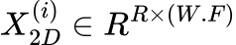
3D Data (Time-Series Representation):
Formula:
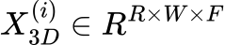

Where:
R: is the number of rows in the train, test, and valid files.
W: is the WINDOW_SIZE, which is 4 for BB and 13 for UD.
F: is the feature importance from the feature engineering described in Table IV.A.2.2.2 for BB and Table IV.A.2.2.1 for UD.

Purpose:
- 2D Data (Flattened): Suitable for traditional machine learning models like SVM, LR, etc.
- 3D Data (Time-Series): Suitable for deep learning models like LSTM, TFM, etc., and for computations with GPU s.

1.1.5 Feature Scaling And Augmentation

1.1.5.1. Standardization
To ensure the model converges effectively and avoid numerical instability during training, feature values are standardized. Standardization transforms the original feature distribution into one with zero mean and unit variance.
Formula:
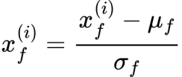
Where:
- are the mean and standard deviation of “” feature for each Ticker.
Description: At this point, the train, test, and valid data files remain in 2D; the 3D version is described by the formula.
2D Data :
Formula:
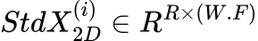
3D Data:
Formula:
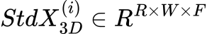
Where:
With being the row number.
Purpose: To help the model converge effectively.

1.1.5.2 SMOTE (Synthetic Minority Over-sampling Technique)
To address the problem of class imbalance particularly when the minority class is underrepresented the SMOTE algorithm is applied to generate synthetic samples by interpolating between neighboring minority class instances for train data-set.
Formula:
Where:
- : is points close to each other in the same class (minority class)
- 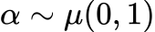: interpolation coefficient.
- 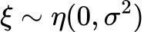: Gaussian noise.
Purpose: New data points are generated to balance the label ratio to 1:1, ensuring stability during training and preventing the model from making biased predictions toward one label.

1.2. Model

1.2.1. Logistic Regression Model

1.2.1.1. Input
The model receives 2D flattened input data, where each sample is represented as a vector of concatenated features across the time window (Bailly et al., 2022).

Formula:
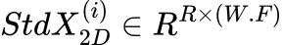

1.2.1.2. Hypothesis Function:
The hypothesis function of Logistic Regression is defined as:
Formula:
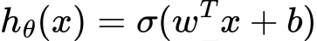, 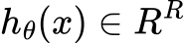
Where:
- 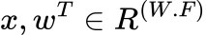is the weight vector.
- is the bias term.
- 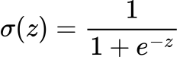 is the sigmoid function.

Input is the standardized data taken from the output of Figure IV.B.1.1, computed using the formula: .

The output  represents the probability of class 1 for each instance (binary classification: 0 or 1).
If needed, the final decision can be made using a threshold:
Formula:
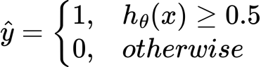

1.2.1.3. Cost Function
The objective of Logistic Regression is to minimize the discrepancy between the predicted probabilities and the actual labels. This is achieved by optimizing the Binary Cross-Entropy loss function, extended with L2 regularization for better generalization.
Formula:
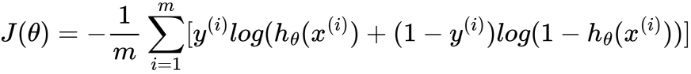

1.2.1.4. Optimization with L2 Regularization:
To prevent over-fitting and promote generalization, L2 regularization is incorporated into the loss function during the training of the Logistic Regression model.
Formula:
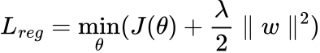

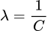
Purpose: Use L2 regularization to gradually shrink the weights, though rarely to zero thus retaining all features.

1.2.1.4. In scikit-learn:
Formula:

Where:
- C: Taken from LR_PARAM_RANGES['C'] – controls the regularization strength
- Smaller C → stronger regularization (helps prevent overfitting)
- Larger C → weaker regularization (model may overfit)

Table IV.B.1.2.1.4: Meaning of parameters in LR_PARAM_RANGES.
Parameter | Description | Explanation
 |  | Regularization L2. Controls model complexity.
Solver | Doesn't change the formula, but affects the optimization approach | Solvers like newton-cg, lbfgs, sag, and saga use gradient-based methods to optimize the loss function.
max_iter | Limits the number of optimization iterations | Stops when either the iteration limit is reached or the algorithm converges.
tol | Convergence criterion: stops when | Smaller values require more precise convergence but take longer to compute.

1.2.2. SVM Model

1.2.2.1. Input

The input for the SVM model is a set of labeled training example .
Where:
: the feature vector of the 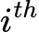sample, where is the product of time steps and features per step.
is the corresponding class label.
The data is often flattened into 2D matrices to be compatible with standard machine learning libraries (Valero-Carreras et al., 2023).
Formula:


1.2.2.2. Hypothesis Function
SVM defines a decision function based on a separating hyperplane:
Formula:
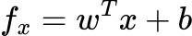
Where:
- 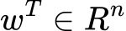 is the weight vector, which defines the orientation of the hyperplane.
- is the bias term, which shifts the hyperplane.

The prediction is determined by the sign of the output:

Formula:
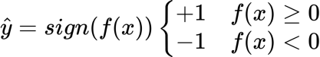

1.2.2.3. Cost Function (Objective with Soft Margin and L2 Regularization)
To address non-separable data, SVM introduces slack variables and optimizes the following objective function:
Formula:
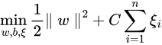
subject to the constraints:
Formula:
Here, is the regularization parameter controlling the trade-off between maximizing the margin and minimizing classification error..

1.2.2.4. Kernel Trick (for Non-linear Separation)
When the data is not linearly separable, a kernel function is used to map the input features into a higher-dimensional space, enabling linear separation:
Formula:
Some commonly used kernel functions include:
- Linear Kernel:Linear Separation
Formula
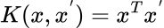
- Polynomial Kernel:Nonlinear, distance based
Formula:
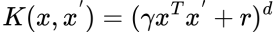
- RBF (Gaussian) Kernel: Nonlinear, infinite-dimensional feature space.
Formula:

1.2.2.5. In scikit-learn:

Table IV.B.1.2.2.5: Meaning of parameters in SVM_PARAM_RANGES.
Parameter | Description | Explanation
C | Regularization parameter | Controls the penalty for misclassified points. A largernarrower margin, fewer misclassifications, but higher risk of over-fitting.
kernel | Type of kernel | Defines the feature mapping indirectly via the kernel trick.
gamma | Parameter for rbf and poly kernels | For rbf: controls the influence range of a single training point. Larger gamma → smaller influence area → higher risk of over-fitting.
tol | Convergence tolerance | Training stops when the change in model parameters becomes smaller than tol. Balances training speed and accuracy.

1.2.3. LSTM Model

1.2.3.1. Input
3D Data (time-series):
From the data taken from Figure IV.B.1.1 for train, test, and valid using the same formula: , The process of converting into batch_size to fit the input format for LSTM model training.
Formula:
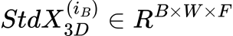
Where:
B là batch_size
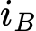 là mini batch_size được tính bởi 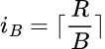.

In which the evaluation process of the metric keeps the train, valid, and test files unchanged”” The entire data-set is passed directly at once without splitting into batch_size. Below is the description of the process as the train file passes through the model training.

1.2.3.2. LSTMCell:
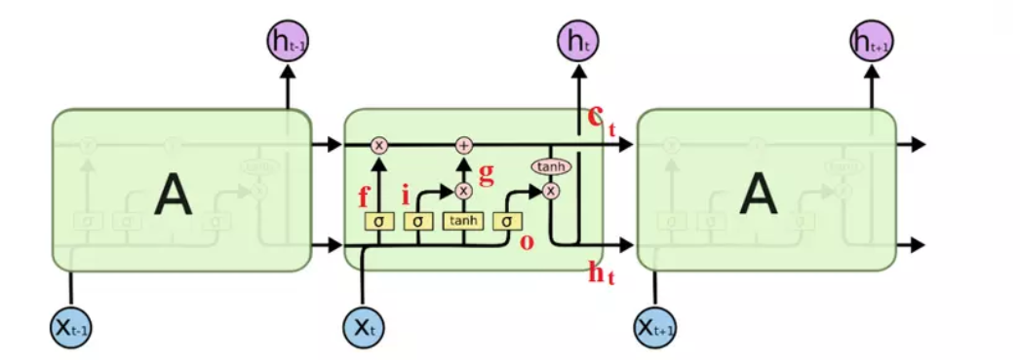
Figure IV.B.1.2.3.2: LSTMCell.
Forget gate:

Formula:

,
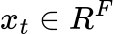, 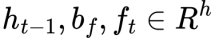, 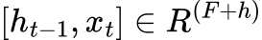, 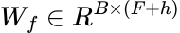
Description: This gate determines which parts of the “” cell state will be forgotten. The inputs include the “” previous hidden state and ““ current input , which are multiplied by weights and passed through a sigmoid function to 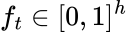, indicating the level of forgetting (Wen & Li, 2023).

Formula:
,
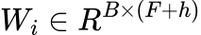, 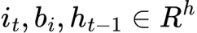, , 
Description: This gate determines what new information will be added to the “” cell state . Similar to the forget gate, it uses a sigmoid function to create a “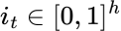” mask for the new information.
Candidate cell state:
Formula:
,
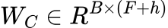, 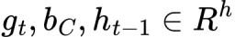, , 
Description: This is a proposed new memory state value, combining the old information and the current input through a “” nonlinear layer.
Update memory status:
Formula:

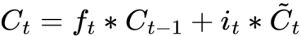,
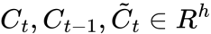

Description: The “” cell state is updated by combining the retained portion from “” and the new information from “” , weighted by “”and “”.
Output gate:
Formula:
,
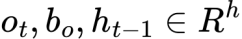, 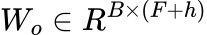, , 

Description: The output gate decides which part of the memory state will be output as the “” current hidden state.
Hidden state:
Formula:

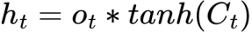,
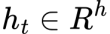
Description:
The “” hidden state is calculated by applying a “” function to the “” current cell state , then multiplying it by the value from the output gate.
Where:
- : sigmoid function
- : element-wise multiplication

1.2.3.3. Forward Pass
Predict the output probability for a binary classification problem.

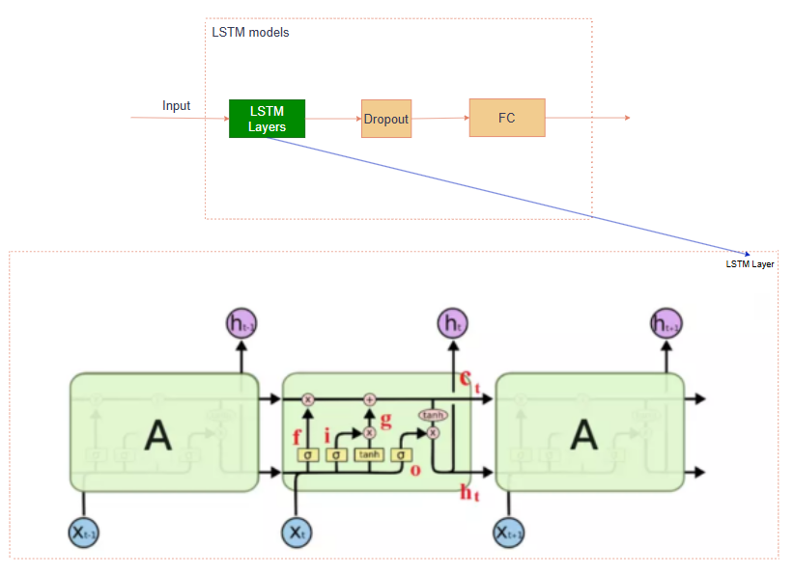
Figure IV.B.1.2.3.3: LSTM Model Architecture 1 (Source: Own work).

Formula:

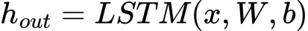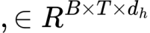

Description: LSTM takes a sequential input in  with batch size “” , time steps “=W”, and “=h” hidden size . The result is a sequence of “” hidden state vectors.
Formula:
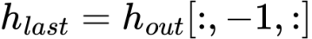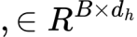

Description: Get the final hidden state of each sequence in the batch, representing the entire sequence.
Formula:
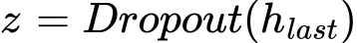
Description: Apply dropout to reduce over-fitting by randomly dropping some nodes in “”.
Formula:
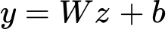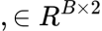
Description: The final linear layer to convert the representation into a probability distribution for 2 binary output classes.

1.2.4. Transformer Model
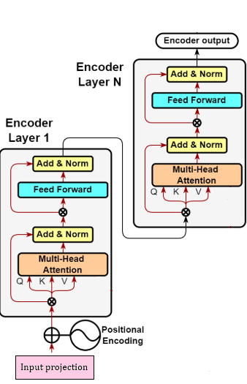
Figure IV.B.1.2.4: Transformer layers.

Purpose: use encoder to apply to model which needs output, (Nassiri & Akhloufi, 2023).

1.2.4.1. Input projection:
In Transformer-based architectures, it is necessary to project input features into a fixed-size representation space before feeding them into the encoder.
This ensures that regardless of the original input dimensional, the model receives inputs of dimension “d_model”, which is essential for multi-head attention and other operations.
3D Data (time-series):
From the data taken from Figure IV.B.1.1 for train, test, and valid using the same formula: , The process of converting into batch_size to fit the input format for training the TFM model.
Formula:

Where:
B là batch_size
 ls mini batch_size calculated by 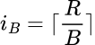.

In which the evaluation process of the metric keeps the train, valid, and test files unchanged “” The entire sample is passed directly at once without splitting into batch_size. Below is the description of the process as the train file passes through the model training.
Formula:

Where:
-
- 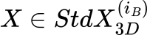
- 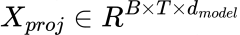
- 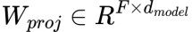
- 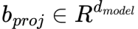
Description: project input vector from input_size to d_model.
Purpose: format input according to Transformer standard..

1.2.4.2. Learnable Positional Encoding:
Formula:

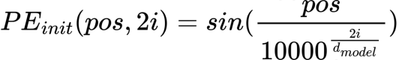
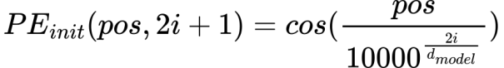
Description: This is a non-learnable (fixed) positional encoding method that uses sine and cosine functions with frequencies that by “” . It helps the model recognize the positional order of elements in the input sequence.

1.2.4.2. Learnable version:
Formula:

,
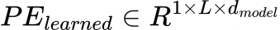, với , L = max_seq_length = =5000
Description: Positional Encoding is initialized using the standard sine-cosine function, then added to a ”” learnable tensor . During training, the model learns to adjust this encoding to better fit the actual data.
Formula:
Description: When applying positional encoding, we only take the first steps corresponding to the actual sequence length by using slicing [:, :T, :].
Purpose: This “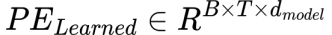” is the positional encoded input, ready for the encoder or decoder block.

1.2.4.3. Transformer Encoder Layer

1.2.4.3.1. Multi-Head Self-Attention
Formula:
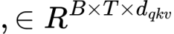, 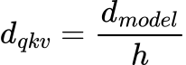
Description: “”is the query, key, and value created from the “” positional encoded input.
Formula:
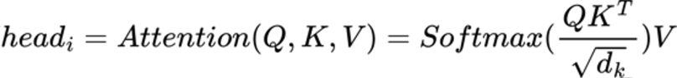
Description: Multiple parallel "heads" are used to learn different relationships between tokens through soft-max.
Formula:
, 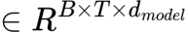
Description: After calculating attention for each head, they are concatenated and multiplied by “” weights to aggregate the information.
Where:
- : “n-head” number of heads
- : rang
- :The aggregated matrix after concatenating all heads.

1.2.4.3. Feed forward
Formula:

, 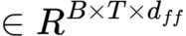.

Description: If “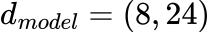” then “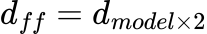” is a step in the Feed-forward to create a larger representation space, helping the model learn deeper nonlinear relationships.
Purpose: To expand the representation space according by “” .
Formula:
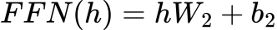, 
Description: After expansion and applying the activation function, this step brings the size back to the “” original dimension to combine with the rest of the network.
Purpose: To restore the representation space.
Layer Normalization:
Formula:
,
Purpose: Normalize the output of the Multi-Head Attention layer to stabilize the training process and accelerate convergence.
Formula:
, 
Purpose: Apply normalization and dropout after the Feed-forward block to stabilize the output and prevent over-fitting.

1.2.4.4. Forward Pass
Predict the output probability for a binary classification problem.
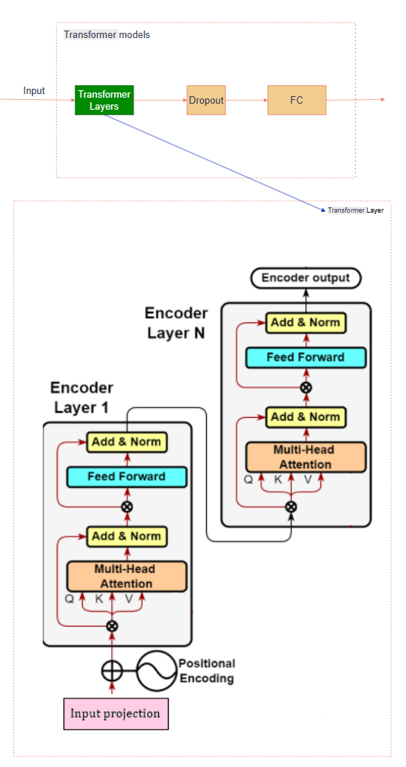
Figure IV.B.1.2.4.4: Transformer Model Architecture (Source: Own work).
Formula
,
Description: Transformer encoder takes a sequential input “” with “” batch size, time steps “”, and “” hidden size . The result is a sequence of “” hidden state vectors.
Formula:
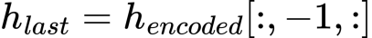, 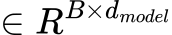
Description: Get the final hidden state of each sequence in the batch, representing the entire sequence.
Formula:
, 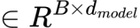
Description: Apply dropout to reduce over-fitting by randomly dropping some nodes in .
Formula:

Description: The final linear layer to convert the representation into a probability distribution for 2 binary output classes.

2. Model training, validation, Testing and inference.

2.1. Optimizer
The main goal of this section is to optimize classic machine learning models (Logistic Regression, SVM) and deep learning models (LSTM, Transformer) to achieve the highest performance in the financial time series classification problem. The optimization is carried out through two main strategies: Random-Search for Logistic Regression and SVM, and Op-tuna for LSTM and Transformer models with the training data-set and test data-set as input.
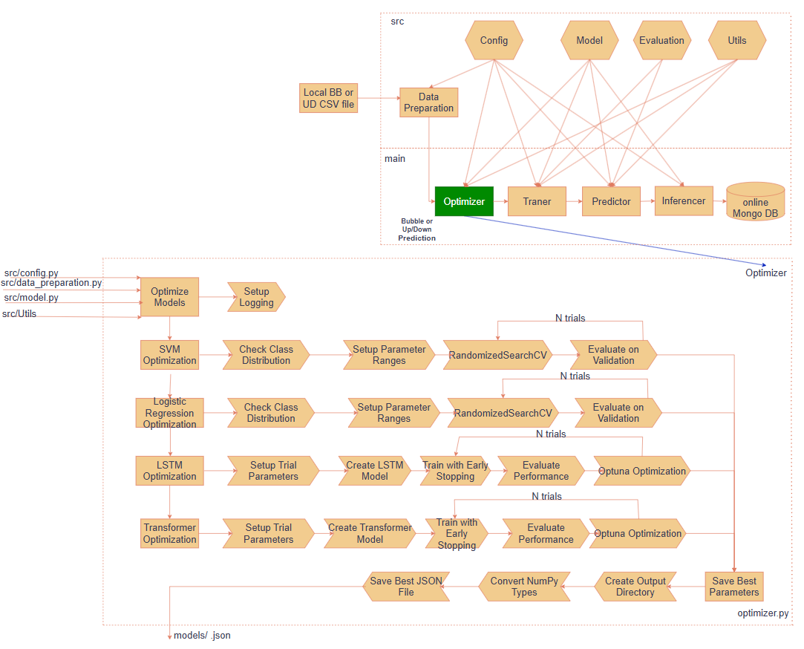
Figure IV.B.2.1: Optimizer (Source: Own work).

2.1.1. Check class Distribution
Before training the model, it is necessary to check the distribution of the target labels in the training set to ensure that both classes are present, avoiding severe imbalance or training errors due to missing classes.

2.1.2. Logistic Regression and SVM

2.1.2.1. Setup parameter ranges
Table IV.B.2.2.2.1 presents the defined hyper-parameter ranges for tuning Logistic Regression (LR) and Support Vector Machine (SVM) models applied to the BB and UD datasets. For LR, the search space includes regularization strength (C), solver types, maximum number of iterations (max_iter), and tolerance (tol), with slightly different ranges between BB and UD. For SVM, the parameter ranges include C, kernel types (linear, rbf, and additionally poly for UD), gamma, and tol. These configurations are set up to optimize model performance during hyper-parameter search.

Table IV.B.2.1.2.1: Setup parameter ranges in LR_SVM_PARAM_RANGES.

BB | UD
LR_PARAM_RANGES = {  'C': np.logspace(-3, -1, 3),  'solver': ['newton-cg', 'lbfgs', 'sag', 'saga'],  'max_iter': [2000, 3000, 5000],  'tol': np.logspace(-3, 1, 5)  }  SVM_PARAM_RANGES = {  'C': np.logspace(-6, -1, 6),  'kernel': ['linear', 'rbf'],  'gamma': np.logspace(-4, 0, 5),  'tol': np.logspace(-3, -1, 3)  } | LR_PARAM_RANGES = {  'C': np.logspace(-4, 2, 7),  'solver': ['newton-cg', 'lbfgs', 'sag', 'saga'],  'max_iter': [1000, 2000, 3000],  'tol': np.logspace(-2, 0, 3)  }  SVM_PARAM_RANGES = {  'C': np.logspace(-4, 2, 7),  'kernel': ['linear', 'rbf', 'poly'],  'gamma': np.logspace(-5, 0, 6),  'tol': np.logspace(-2, 2, 5)  }

2.1.2.2. Random-Search
To enhance the predictive performance of the Logistic Regression and SVM models, hyper-parameter tuning is conducted using the Random Search strategy.
Random Search is a stochastic optimization technique that randomly samples a fixed number of parameter combinations from the defined search space and selects the best-performing configuration based on a target evaluation metric.
In this project, the optimization objective is to maximize the weighted F1-score on the training data-set.
Formula:
Where:
- is the parameter space
- Select random in the space set with =180:



Purpose: find the best parameters with the goal of maximizing F1-score.

2.1.3. LSTM and Transformer:

2.1.3.1. Setup parameter ranges
Table IV.B.2.1.3.1: Setup parameter ranges in LSTM_TFM_PARAM_RANGES.

BB | UD
LSTM_PARAM_RANGES = {  'hidden_size': (8, 24),  'num_layers': (1, 2),  'dropout': (0.3, 0.7),  'learning_rate': (0.0001, 0.001),  'batch_size': [4, 8],  'weight_decay': (1e-4, 1e-1)  }  TRANSFORMER_PARAM_RANGES = {  'd_model': (8, 24),  'num_layers': (1, 2),  'dropout': (0.3, 0.7),  'learning_rate': (0.0001, 0.001),  'batch_size': [4, 8],  'nhead': [2],  'weight_decay': (1e-4, 1e-1)  } | LSTM_PARAM_RANGES = {  'hidden_size': (32, 96),  'num_layers': (1, 2),  'dropout': (0.2, 0.5),  'learning_rate': (0.0005, 0.002),  'batch_size': [16, 32, 64],  'weight_decay': (1e-4, 1e-2)  }  TRANSFORMER_PARAM_RANGES = {  'd_model': (32, 96),  'num_layers': (1, 2),  'dropout': (0.2, 0.5),  'learning_rate': (0.0005, 0.002),  'batch_size': [16, 32, 64],  'nhead': [2, 4],  'weight_decay': (1e-4, 1e-2)  }

2.1.3.2. Op-Tuna
The optimization objective is to minimize the validation loss during model training.
Formula:
Where:
- is the parameter space
- Select random in the space set with =40:

Purpose: find the best parameters with the goal of minimizing the loss function on the valid data set.

2.1.4. Train the LSTM, Transformer model
After selecting the optimal hyper-parameters, the LSTM and Transformer models are trained on the training set using mini-batch gradient descent with the Adam optimizer.
The parameter set 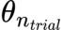 in each epoch with mini-batch size :
Formula:
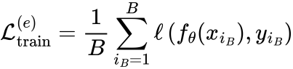
Adam Optimizer:

Formula:
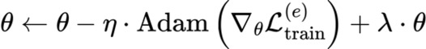
Calculate loss on valid data:

Formula:

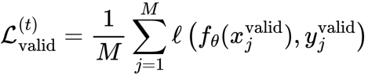

Where:
- : at the time of epoch trial
- : The number of samples in the validation set.
- : minibatch size train dataset

Early Stopping :
- LSTM_EPOCHS_OPTIMIZED = 111
- LSTM_EPOCHS_TRAINED = 111
- TRANSFORMER_EPOCHS_OPTIMIZED = 111
- TRANSFORMER_EPOCHS_TRAINED = 111
Stop training if validation loss does not improve after a number of rounds (patience=10).
Formula:
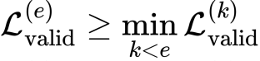
Where:
- : is the previous epoch if then stop. This also serves as the basis for saving the model parameters.
2.1.5. Input-Output
Input: Train data-set, Valid data-set from section 1.1 Data preparation.
Output: Best parameter at Table IV.B.2.1.2.1 for model (LR, SVM), Table IV.B.2.1.3.1 for model (LSTM, TFM).

2.2. Trainer
The Trainer process is responsible for training the model for each stock ticker based on the parameter set defined in the JSON files. These parameters are extracted and processed similarly to the optimization process (Optimizer) to retrain the models over a defined number of iterations (N trials), thereby creating models and generating prediction results on the validation data-set (Valid).
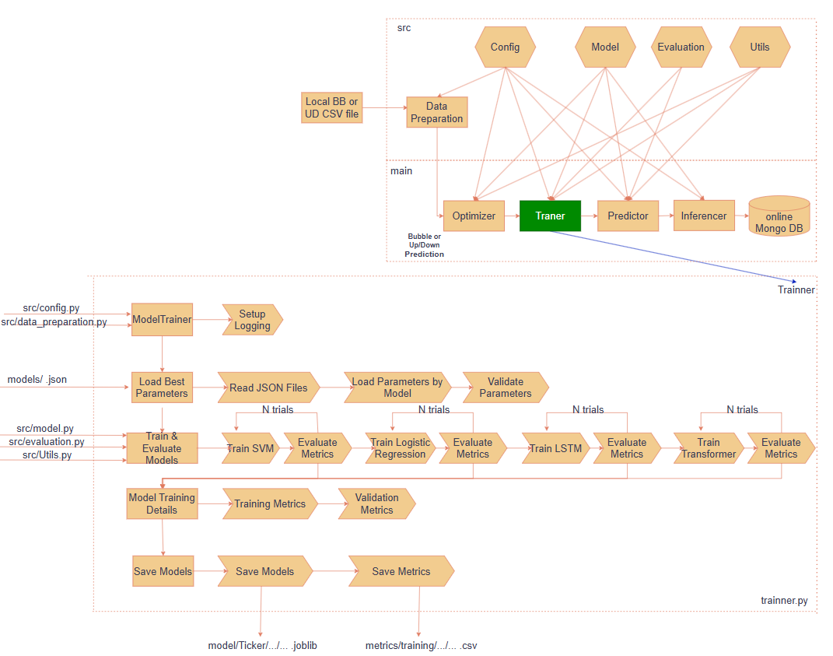
Figure IV.B.2.2: Trainer (Source: Own work).
The process starts with loading the configurations (config.py) and preparing the data from the CSV files generated in the previous data preparation step (from BB or UD source). Then, the system reads the JSON file containing the best parameters for each ticker, breaks them down by model, and performs training for the models: SVM, Logistic Regression, LSTM, and Transformer. Each model will be trained multiple times (N-trials), followed by performance evaluation using metrics such as Accuracy, Precision, Recall, and F1. The formulas are presented in section 3.1. Evaluate Metrics.
g is complete, the system will perform the following steps:
- Save the trained model in .joblib format (folder model/Ticker/...).
- Save the training and validation evaluation metrics into a .csv file (folder metrics/training/...).
- Generate a summary report to facilitate the evaluation and selection of the best model in the Optimizer.
Trainer Input:
Similar to the Optimizer section 2.1.5. Input-Output.

Metrics Output:
The evaluation results of the 4 models are saved in a CSV file with the following columns:
{Ticker, Model, Dataset, Accuracy, Precision, Recall, F1}

2.3 Predictor.
This process involves loading the model and testing it with the test set that has never been input into the model before. The goal is to compute the evaluation metrics and select the best model based on the test results with the F1 score. The selected model will be used for the inference step (Inferencer) to output the final prediction.
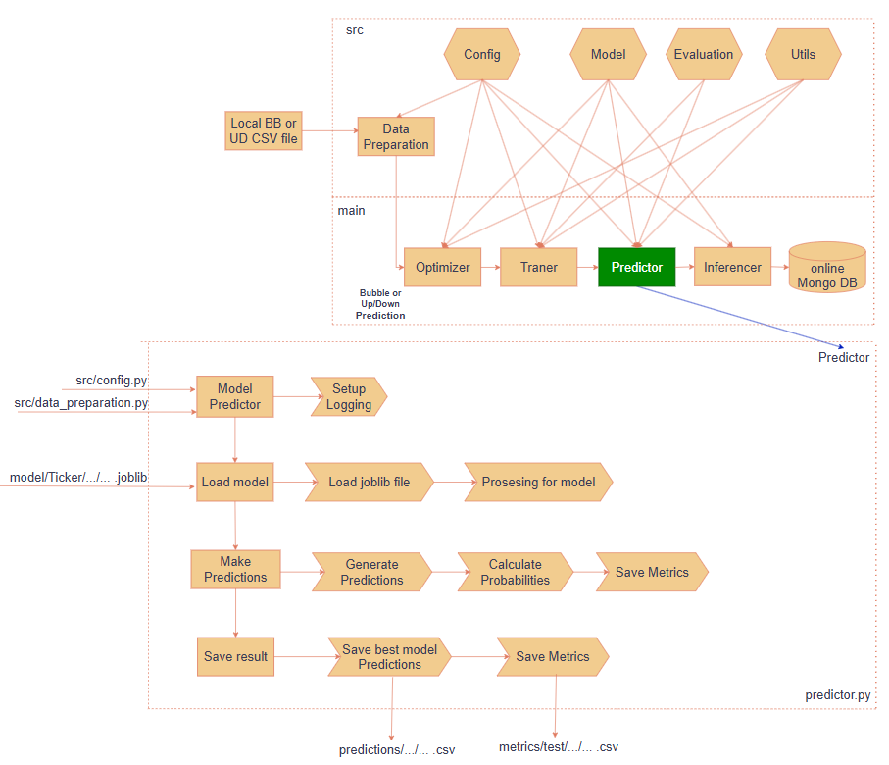
Figure IV.B.2.3: Predictor (Source: Own work).
The process starts by loading the configuration files (config.py), preparing the input data from the CSV files generated by the previous pipeline (BB or UD), and then loading the pre-trained models (in .joblib format). Each model is then tested on the corresponding test set to generate predictions and prediction probabilities for each class.

After completion, the program will:
- Save the prediction results as a CSV file (predictions/...csv).
- Compute evaluation metrics such as accuracy, precision, recall, etc., and save them to a file (metrics/test/...csv).
- Save the predictions of the best model as a basis for use in the Inference process.
Prediction Input:
The data is the test set, from which the last row, the most recent data point without a label has been removed. This row had been temporarily labeled during section 1.1.2.2. Label shift.
Prediction Output:
The results are stored in a CSV file with the following columns:
{Ticker, Model, Month-year, Index, Actual, Prediction, Prob_Class_0, Prob_Class_1, Correct}
Metrics Output:
The evaluation results from the 4 participating models are saved in a CSV file with the following columns:
{Ticker, Model, Dataset, Accuracy, Precision, Recall, F1}

2.4 Inferencer

2.4.1 Inference.
The Inference process is the final step in the pipeline, where the system uses the best model (selected based on F1-score from the Predictor step) to generate final predictions for new or evaluation data. The goal of this step is to produce prediction results from the trained model and save them in CSV/JSON format for use in storage or subsequent processes.
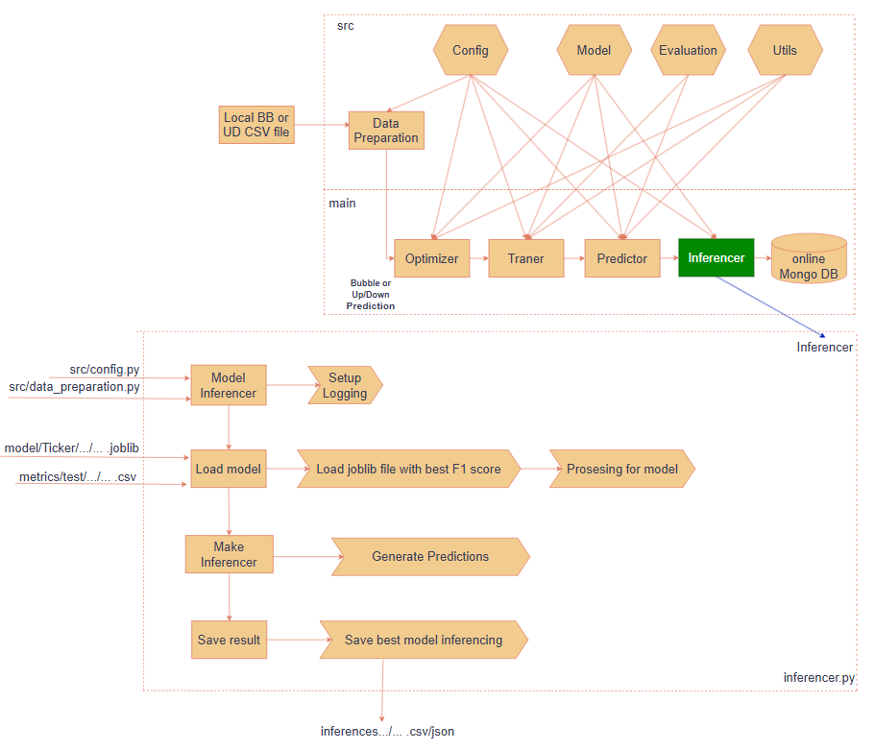
Figure IV.B.2.4.1: Inferencer (Source: Own work).
The process begins by loading the configuration files (config.py) and initializing the logging system. Then, the system will:
- Load the .joblib model with the highest F1-score from the previous evaluation step.
- Preprocess the input data to be compatible with the selected model.
- Generate predictions using the best model.
- Save the prediction results into the inferences/... folder in .csv or .json format.

Inference Input:
Similar to the Predictor from section 2.3 Predictor, but this time the last date of test data-set is used for inference.

Inference Output:
The final result from the inference process is saved in .csv or .json format with the following fields:
{Ticker, Model, Prediction, F1_score , Confidence}
To use the model with the highest F1-score based on the test set to generate final predictions on new data, ensuring that the system produces accurate forecasts that can be used in real-world environments or to store prediction results one week in advance for UD, and one month in advance for BB, based on the latest Feature Engineering data update. From there, the inference results are uploaded to MongoDB for utilization. This method enables instantaneous retrieval of predictions for all tickers due to the fixed nature of the input for this task.

2.4.2 Push Data to MongoDB.
After the Inference process is completed and the prediction result files (.csv) are generated, the system proceeds to the Push to MongoDB step to store these results in the MongoDB database. The main goal of this step is to convert the result format appropriately and push the data into MongoDB to support later retrieval, analysis, and visualization (an API will be deployed in the next step).
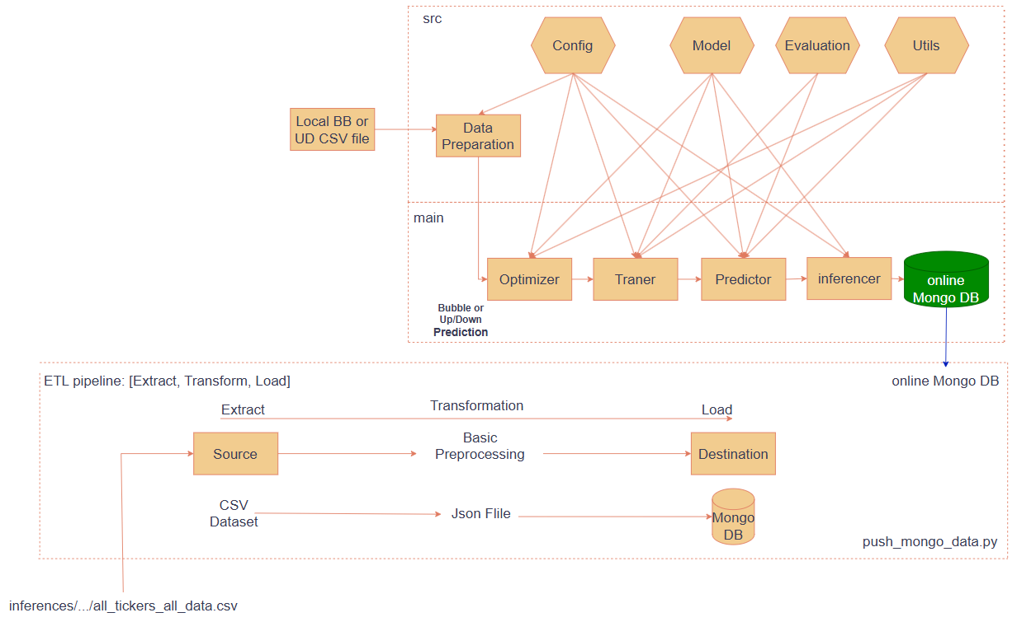
Figure IV.B.2.4.2: Push data to mongo DB (Source: Own work).
The process includes three main stages in the ETL pipeline (Extract - Transform - Load):
- Extract: Read input data from CSV files containing prediction results (inferences/.../all_tickers_all_data.csv).
- Transform: Perform basic preprocessing and convert the data format from CSV to JSON.
- Load: Write the processed JSON data into MongoDB, organized by each Ticker and corresponding model.
MongoDB Output: The data is stored in JSON format and organized by collection in MongoDB. Each record will contain fields such as.
{Ticker, Model, Prediction, F1_score , Confidence}
To ensure that the system can access and manipulate the data quickly and flexibly in the subsequent steps, such as exporting data via the API in section 4. Implementation Plan, or querying for periodic analysis.

3. Evaluation metrics

3.1. Evaluate Metrics:

3.1.1. Accuracy:
Accuracy measures the proportion of correctly predicted instances out of the total instances.
Formula:

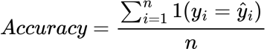

3.1.2. Precision
Precision evaluates the proportion of true positive predictions among all predicted positive instances. In this project, weighted precision is calculated to account for class imbalance.
Formula:
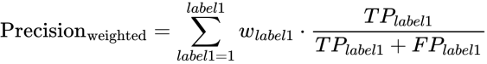

3.1.3. Recall
Recall measures the proportion of true positive instances that are correctly identified by the model.
Formula:
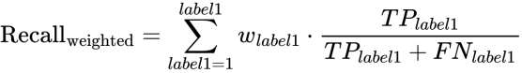

3.1.4. F1-score
The F1-score is the harmonic mean of Precision and Recall, providing a balanced measure between the two.
Formula:
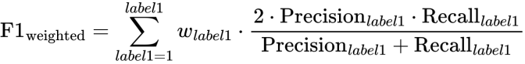
Purpose: add 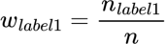(In some evaluation cases, only the bubble label appears in the BB (Bubble) valid, test data-set.)for BB. In UD case not used . Find the best parameters with the goal of minimizing the loss function on the valid data-set (LSTM, Transformer Model) and maximizing F1 Score (LR, SVM Model).

3.2. Detailed results evaluation

BB Statistics Description:
The BB data-set shows high performance on the training set, with an average Accuracy and Recall of approximately 84%, and an F1-score of 83.12%. On the validation set, the performance decreases moderately, with Accuracy around 66.52% and F1-score at 63.44%, indicating a slight generalization gap. On the test set, the average Accuracy and Recall drop to around 57.3%, and the F1-score falls to 53.26%, suggesting challenges in maintaining model robustness on unseen data.
Train data-set:
Table IV.B.3.2.a: BB STATISTICS DESCRIPTION Train dataset.
Metric | Count | Mean | Std | Min | 25% | 50% | 75% | Max
Accuracy | 2822.0000 | 0.8452 | 0.1567 | 0.0548 | 0.7979 | 0.8904 | 0.9524 | 1.0000
Precision | 2822.0000 | 0.8465 | 0.1770 | 0.0030 | 0.8126 | 0.8956 | 0.9545 | 1.0000
Recall | 2822.0000 | 0.8452 | 0.1567 | 0.0548 | 0.7979 | 0.8904 | 0.9524 | 1.0000
F1 | 2822.0000 | 0.8312 | 0.1806 | 0.0057 | 0.7938 | 0.8846 | 0.9511 | 1.0000

Valid data-set:
Table IV.B.3.2.b: BB STATISTICS DESCRIPTION Valid dataset.
Metric | Count | Mean | Std | Min | 25% | 50% | 75% | Max
Accuracy | 2822.0000 | 0.6646 | 0.2763 | 0.0000 | 0.4839 | 0.7097 | 0.9032 | 1.0000
Precision | 2822.0000 | 0.6786 | 0.3242 | 0.0000 | 0.4436 | 0.8065 | 0.9702 | 1.0000
Recall | 2822.0000 | 0.6646 | 0.2763 | 0.0000 | 0.4839 | 0.7097 | 0.9032 | 1.0000
F1 | 2822.0000 | 0.6339 | 0.3030 | 0.0000 | 0.4209 | 0.6757 | 0.9043 | 1.0000

Test data-set:
Table IV.B.3.2.c: BB STATISTICS DESCRIPTION Test dataset.
Metric | Count | Mean | Std | Min | 25% | 50% | 75% | Max
Accuracy | 2818.0000 | 0.5699 | 0.3348 | 0.0000 | 0.3103 | 0.5862 | 0.8966 | 1.0000
Precision | 2818.0000 | 0.5753 | 0.3899 | 0.0000 | 0.1712 | 0.6427 | 1.0000 | 1.0000
Recall | 2818.0000 | 0.5699 | 0.3348 | 0.0000 | 0.3103 | 0.5862 | 0.8966 | 1.0000
F1 | 2818.0000 | 0.5316 | 0.3566 | 0.0000 | 0.2086 | 0.5365 | 0.8978 | 1.0000

UD Statistics Description:
For the UD data-set, the training set results are moderate, with an average Accuracy of 72.77% and an F1-score of 71.85%. On the validation set, the metrics decrease to an Accuracy of around 55.46% and an F1-score of 54 .30%, showing a notable gap between training and validation performance. Similarly, on the test set, the Accuracy is approximately 54.96% and the F1-score is 47.50%, indicating difficulties in generalizing to new data and potential over-fitting.
Train data-set:

Table IV.B.3.2.d: UD STATISTICS DESCRIPTION Train dataset.
Metric | Count | Mean | Std | Min | 25% | 50% | 75% | Max
Accuracy | 2860.0000 | 0.7277 | 0.1573 | 0.4677 | 0.5910 | 0.6973 | 0.8230 | 1.0000
Precision | 2860.0000 | 0.7344 | 0.1633 | 0.0000 | 0.6015 | 0.7111 | 0.8408 | 1.0000
Recall | 2860.0000 | 0.7195 | 0.2017 | 0.0000 | 0.5972 | 0.7247 | 0.8469 | 1.0000
F1 | 2860.0000 | 0.7185 | 0.1831 | 0.0000 | 0.5963 | 0.6993 | 0.8260 | 1.0000

Valid data-set:

Table IV.B.3.2.e: UD STATISTICS DESCRIPTION Valid dataset.
Metric | Count | Mean | Std | Min | 25% | 50% | 75% | Max
Accuracy | 2860.0000 | 0.5546 | 0.1394 | 0.0222 | 0.4778 | 0.5333 | 0.6000 | 1.0000
Precision | 2860.0000 | 0.5884 | 0.2279 | 0.0000 | 0.5102 | 0.5926 | 0.7070 | 1.0000
Recall | 2860.0000 | 0.5777 | 0.3340 | 0.0000 | 0.3265 | 0.5955 | 0.9044 | 1.0000
F1 | 2860.0000 | 0.5430 | 0.2642 | 0.0000 | 0.4058 | 0.5936 | 0.7286 | 1.0000

Test data-set:

Table IV.B.3.2.f: UD STATISTICS DESCRIPTION new test dataset.
Metric | Count | Mean | Std | Min | 25% | 50% | 75% | Max
Accuracy | 2856.0000 | 0.5496 | 0.1781 | 0.0227 | 0.4545 | 0.5227 | 0.6136 | 0.9773
Precision | 2856.0000 | 0.5063 | 0.3114 | 0.0000 | 0.3500 | 0.5484 | 0.7087 | 1.0000
Recall | 2856.0000 | 0.5342 | 0.4047 | 0.0000 | 0.0833 | 0.5600 | 1.0000 | 1.0000
F1 | 2856.0000 | 0.4750 | 0.3296 | 0.0000 | 0.1429 | 0.5455 | 0.7353 | 0.9885

- Average score of all models by BB, UD
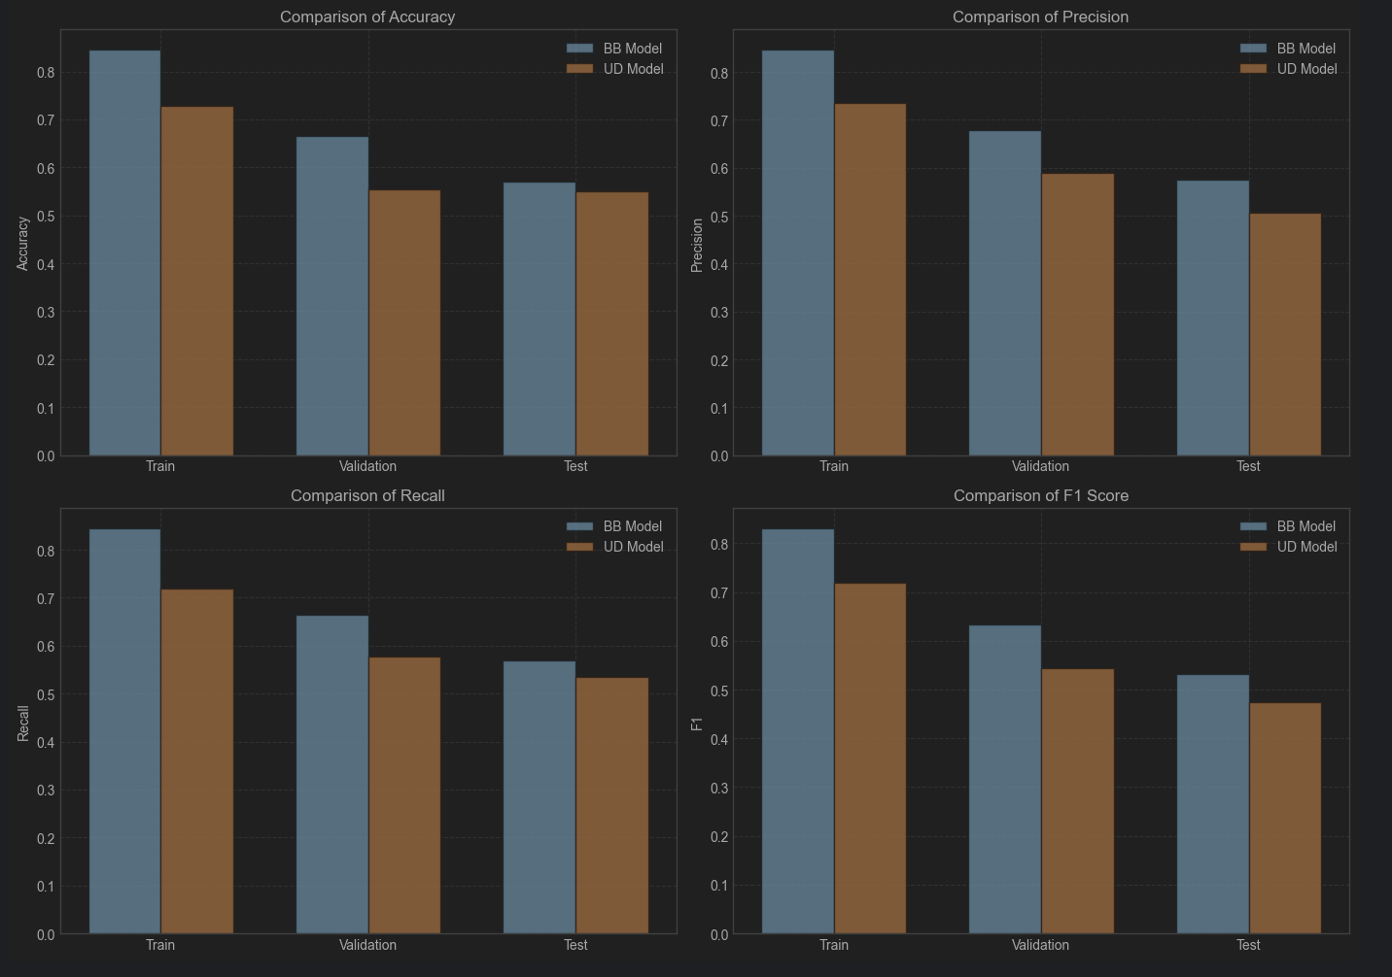
Figure IV.B.3.2: Average score of all models by BB, UD.

About each model:
Based on the results in the tables, the SVM model demonstrates outstanding performance in both the BB and UD tasks. Specifically, in the BB task, SVM achieves an F1-score of 0.500861 on the test set, which is relatively competitive with LSTM (0.564579) and Transformer (0.567880). In the UD task, however, SVM achieves an F1-score of 0.628251 — the highest among all models. This indicates that SVM is an effective choice for both general and user-specific contexts.

On the other hand, the Transformer and LSTM models perform quite well in the BB task with F1-scores of 0.567880 and 0.564579 respectively, but their performance drops significantly in the UD task, down to around 0.403281 and 0.378944 on the test set. The Logistic Regression model shows average performance across both tasks, with F1-scores of 0.549096 (BB) and 0.489431 (UD). Overall, SVM is the most stable and effective model, especially in user-dependent scenarios. I believe classification algorithms are well-suited for this type of classification problem. To achieve higher performance, we can consider improving input data engineering and experimenting with new model architectures based on Transformers trained on the entire data-set to fully leverage the power of the algorithm. After is result of each model
BB:
Table IV.B.3.2.g: TRAIN BB Model.
Model | Accuracy | Precision | Recall | F1
logistic_regression | 0.889758 | 0.887564 | 0.889758 | 0.883966
lstm | 0.817888 | 0.804701 | 0.817888 | 0.789615
svm | 0.896488 | 0.900224 | 0.896488 | 0.892372
transformer | 0.787603 | 0.803699 | 0.787603 | 0.768597

Table IV.B.3.2.h: VALID BB Model.
Model | Accuracy | Precision | Recall | F1
logistic_regression | 0.638059 | 0.656900 | 0.638059 | 0.607928
lstm | 0.700050 | 0.701362 | 0.700050 | 0.668190
svm | 0.632148 | 0.652474 | 0.632148 | 0.596020
transformer | 0.689237 | 0.708925 | 0.689237 | 0.662871

Table IV.B.3.2.l: TEST BB Model.
Model | Accuracy | Precision | Recall | F1
logistic_regression | 0.585466 | 0.592871 | 0.585466 | 0.549096
lstm | 0.599760 | 0.605624 | 0.599760 | 0.564579
svm | 0.542781 | 0.535228 | 0.542781 | 0.500861
transformer | 0.600654 | 0.625636 | 0.600654 | 0.567880

UD:
Table IV.B.3.2.m: TRAIN UDModel.
Model | Accuracy | Precision | Recall | F1
logistic_regression | 0.725672 | 0.730177 | 0.730258 | 0.729163
lstm | 0.633175 | 0.646989 | 0.599705 | 0.608970
svm | 0.933578 | 0.932584 | 0.940666 | 0.936257
transformer | 0.618529 | 0.627761 | 0.607323 | 0.599788

Table IV.B.3.2.n: VALID UDModel.
Model | Accuracy | Precision | Recall | F1
logistic_regression | 0.541463 | 0.609428 | 0.558206 | 0.561484
lstm | 0.545988 | 0.569236 | 0.492757 | 0.476405
svm | 0.585248 | 0.615990 | 0.782599 | 0.666237
transformer | 0.545773 | 0.558957 | 0.477211 | 0.467755

Table IV.B.3.2.o: TEST UDModel.
Model | Accuracy | Precision | Recall | F1
logistic_regression | 0.531389 | 0.552830 | 0.521298 | 0.489431
lstm | 0.537768 | 0.426150 | 0.413812 | 0.378944
svm | 0.587798 | 0.589134 | 0.765036 | 0.628251
transformer | 0.541312 | 0.589134 | 0.436763 | 0.403281

4. Implementation plan

4.1. Explanation for Choosing the Appropriate Deployment Method.
Due to the complexity of the data transformation process that generates features before entering the model, as well as the in-feasibility of directly inputting data for the model from a user, the input data “Local BB or UD CVS file” in Figure IV.B.1.1 already covers all the options that users can input.
If we were to use the inference method: Taking the latest data from feature engineering (“Local BB or UD CVS file” Figure IV.B.1.1) to predict for 1 point per week for UD and 1 point per month for the most recent BB, the processing time would be too long for the task of retrieving all stock tickers via the API. During test trials, it took 5 minutes for monthly BB data and longer for weekly data for all tickers.
We propose the solution of using the Inferencer locally first instead of deploying it online and then exporting the results to MongoDB, as shown in Figure IV.B.2.4.1
{Ticker, Model, Prediction, F1_score , Confidence}

From the first program, data is pushed to the MongoDB database. Then, the second program implements the deployment steps, including retrieving data from MongoDB, deploying the application on the AWS platform, and using supporting tools and technologies such as GitHub, Amazon ECR, EC2, and designing API s (Fast-API) for data querying.

4.2. Deploy: to AWS

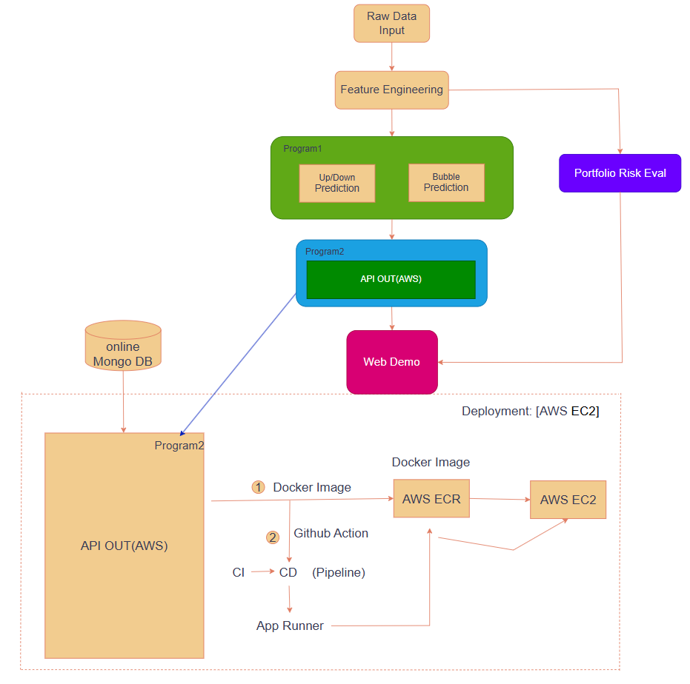
Figure IV.B.4.2: Form GitHub push ECR and run EC2 (Source: Own work).
The deployment process mainly uses tools, so describing it step by step would be too lengthy. Therefore, we provide a simplified description of the process through Figure IV.B.4.2 and Deployment: [AWS EC2].
The application deployment process is carried out through Docker. The entire source code is packaged into a Docker Image, which is then pushed to AWS ECR (Elastic Container Registry) for storage. From ECR, the Docker Image can be deployed to AWS EC2. This entire process is automated using GitHub Actions integrated with CI/CD or using App Runner to automatically build, test, and deploy the application whenever there is a change in the source code. Below is the process of packaging through Docker Image.

4.2.1. Docker Image.
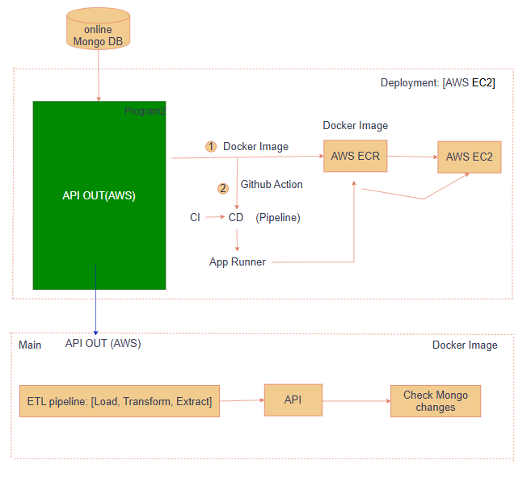
Figure IV.B.4.1.a. Docker Image.
The main workflow of the system:
The system operates based on a main processing flow, where data is retrieved directly from the online MongoDB database. After collection, the data is fed into the ETL pipeline to perform the Load, Transform, and Extract steps for data normalization and processing. The processed data is then made available through an API deployed on the AWS platform (API OUT). Additionally, the application continuously monitors changes in MongoDB to promptly update new data.
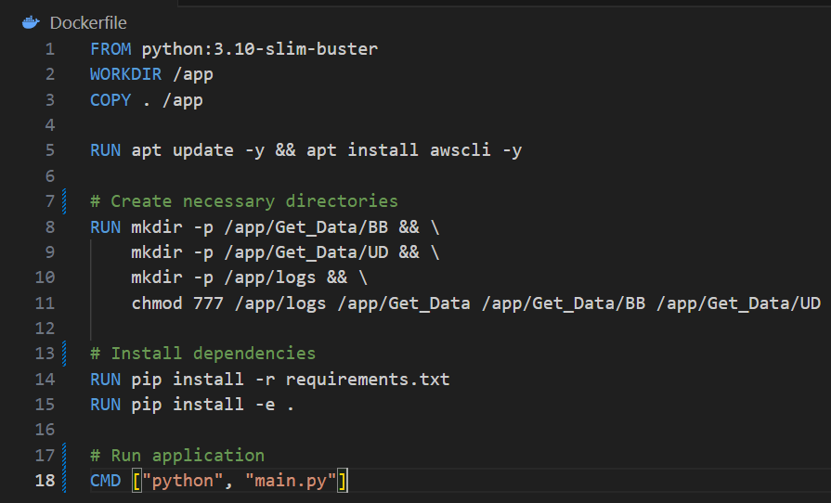
Figure IV.B.4.1.b. Docker Image.

Dockerfile:
The Docker-file shown below illustrates the process of configuring the container, starting from the base image python:3.10-slim-buster. The source code is copied into the /app directory in the container. Next, necessary tools such as awscli are installed, and directories required for the pipeline, such as /app/Get_Data/BB, /app/Get_Data/UD, and /app/logs, are created with appropriate access rights. After that, the dependencies listed in requirements.txt are installed, and the main application is launched with the command CMD ["python", "main.py"].

4.2.2. Get mongo data
After the data has been pushed to MongoDB from the Inferencer step, the system needs to have a periodic mechanism to retrieve the latest data from MongoDB, serving purposes such as API output, synchronization for analysis, or displaying on a dashboard interface.
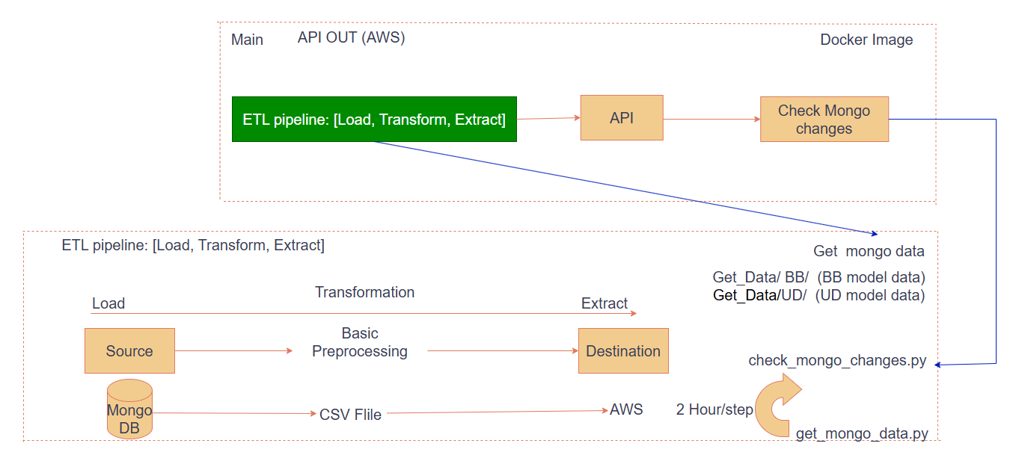
Figure IV.B.4.2.2: Get mongo data (Source: Own work).
This process works based on the reverse ETL principle (Load – Transform – Extract), occurring in cycles (every 2 hours), and includes the following main steps:
Load: Query and load data from MongoDB corresponding to each model and ticker (through the functions Get_Data/BB, Get_Data/UD)
Transform: Perform basic data preprocessing steps such as cleaning, standardizing formats, and removing duplicate records
Extract: Write the data to a .csv file or other compatible formats to prepare for API distribution or further analysis.
Detailed Pipeline:
Module: get_mongo_data.py
Change Check: check_mongo_changes.py to only fetch records that have been updated since the last access.
Output Format: CSV file or Data-frame for the API in section 4.2.3. API.
Frequency: Every 2 hours (adjustable).
Purpose:
Ensure the system always has the most up-to-date data available to serve end-users and other integrated systems. This step is crucial for maintaining synchronization between stored data and the data being queried/displayed.

4.2.3. API
This API retrieves data directly from the CSV files in Get_Data/BB and Get_Data/UD, and then serves it through an endpoint.
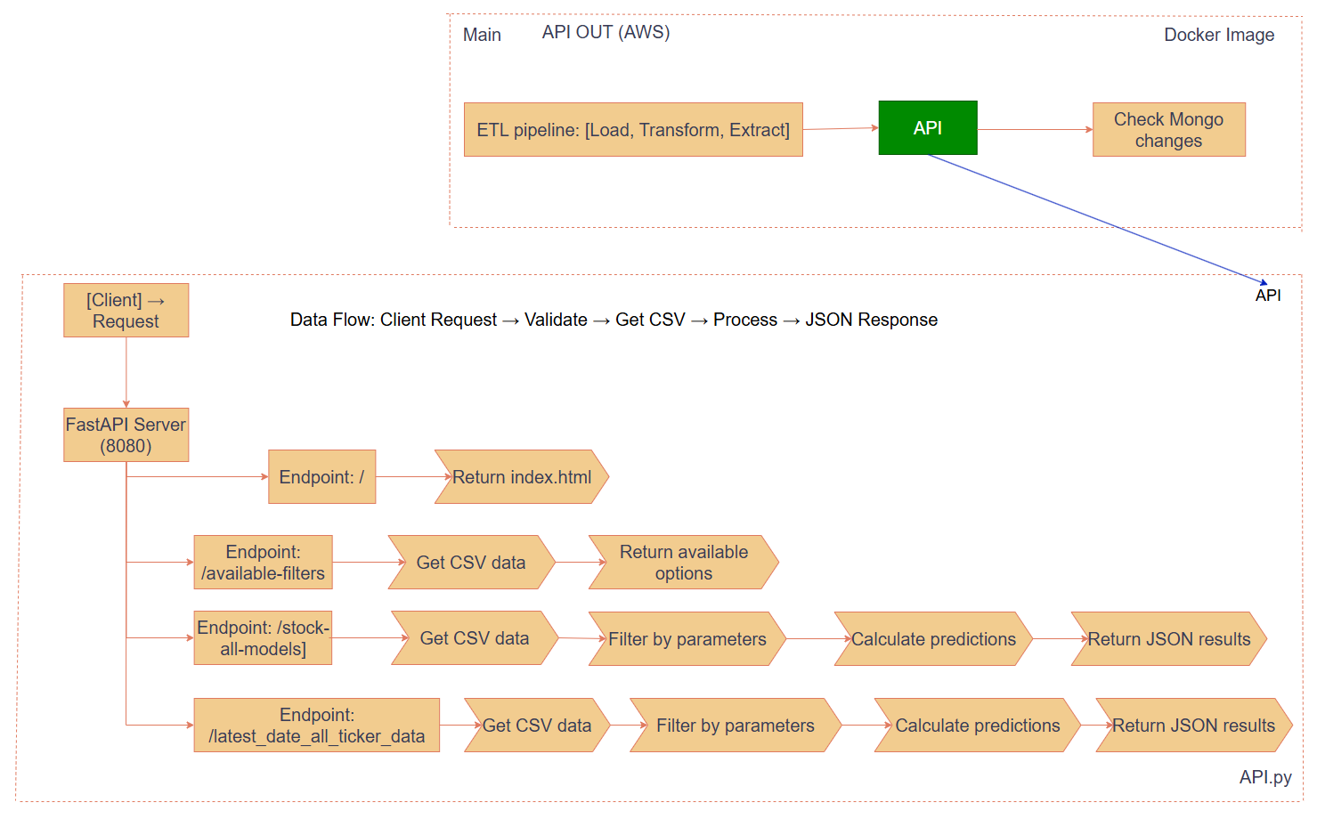
Figure IV.B.4.2.3: API. for BB, UD (Source: Own work).
Description: Design and deploy RESTful API s to facilitate communication between the front-end and back-end. These API s allow users or other systems to send requests and receive responses via the HTTP protocol. The API s can be built using Fast-API and containerized for deployment.
2 main endpoints:
Endpoint 2. GET /stock-all-modelsDescription:
Description: Retrieves prediction data from all models for a specific stock ticker.
Query Parameters:
- ticker (required): The stock symbol (e.g., VNM, FPT).
- market_state (required): The market state ("BB" or "UD").
- month_year (optional): The date filter (e.g., "2024-03-01").
Response: Returns:
- Prediction results for all models
- Model statistics
Endpoint 2. GET /latest-date-all-ticker-data
Description: Fetches the most recent data for all stock tickers within a given market state.
Query Parameters:
- market_state (required): Specifies the market condition ("BB" or "UD").
Response: Returns the latest available prediction data for each stock, including:
- Model information
- Forecast details

5.Ethical Considerations

5.1. Data Privacy and Security
The collection and processing of stock market data raise several privacy concerns, particularly regarding:
- Information Security: Data stored in MongoDB and transmitted via API s must be encrypted and protected to prevent leaks of sensitive information.

5.2. Model Accuracy and Transparency
Financial market prediction models directly influence investment decisions; therefore:
- Evaluation Transparency: It is essential to provide users with full evaluation metrics (accuracy, precision, recall, F1-score) to ensure they understand the model's reliability.
- Model Limitations: Clarify that the model only predicts market states (bubble/crash or up/down), not specific price values.
- Avoiding Misconceptions: Warn users about the possibility of model errors, especially during unusual market conditions.

5.3. Fairness and Non-Discrimination
Although the model focuses on market data, it must ensure:
- Market Neutrality: Ensure the model does not favor large companies or specific industries.
- Data Diversity: Use data from a wide range of stocks to ensure the model is broadly representative.

5.4. Market Impact and Social Responsibility
Prediction models can cause self-fulfilling prophecies:
- Herd Behavior: Predicting a “bubble” might trigger panic selling, potentially leading to actual market crashes.
- Market Stability: Consider the impact of public predictions on the stability of the financial market.
- Social Responsibility: Provide warnings and guidelines for responsible use of predictions.

5.5. Continuous Monitoring and Improvement
To ensure the system’s ethical integrity over time:
- Performance Monitoring: Continuously monitor model performance to detect and fix issues.
- Model Updates: Regularly update the model with new data to keep it relevant to current market conditions.

5.6. Abuse Prevention and Manipulation Control
Measures to prevent misuse of the prediction system include:
- API Access Limiting: Implement reasonable access rate limits to prevent system abuse.
- Data Source Transparency: Clearly disclose the sources of data used for model development.

C. Multi-Factor Model for Portfolio Return Explanation and Prediction
This section elucidates the methodology, implementation, and ethical considerations underpinning the multi-factor model developed for explaining and predicting portfolio returns. We detail the selection of relevant financial factors, the specific modeling techniques employed, the process of model training and evaluation, and the metrics utilized to assess performance. Furthermore, crucial ethical and safety considerations pertinent to the model's development and application are addressed.

1. Feature and Technique Selection
The model integrates a set of well-established financial factors, providing granular insights into portfolio return dynamics. These factors are chosen based on robust financial theory and substantial empirical evidence demonstrating their explanatory power across the cross-section of stock returns. The included factors are:
- Market Risk (Mkt): Representing the market's excess return over the risk-free rate, this factor captures overall systematic risk.
- Size: Quantifying the relative performance of small-capitalization versus large-capitalization stocks.
- Value: Measuring the outperformance of value stocks (characterized by a high book-to-market ratio) compared to growth stocks (low book-to-market ratio).
- Momentum (Mom): Capturing the empirical tendency of past high-performing stocks to continue their outperformance.
- Investment (Inv): Reflecting the superior returns of companies adopting conservative investment strategies.
- Profit: Measuring the outperformance observed in more profitable firms.
Historical values for these factors are sourced from the final_five_factors.csv file.
The primary modeling technique employed for factor analysis is Ordinary Least Squares (OLS) regression. This method is implemented using sklearn.linear_model.LinearRegression and statsmodels.api.sm.OLS libraries in Python. OLS regression estimates the linear relationship between a portfolio's excess returns and the selected factors, with the resulting coefficients (betas) indicating the portfolio's sensitivity to each specific factor. Linear regression is favored for its clear interpretability of factor exposures, which facilitates a deeper understanding of the underlying drivers of a portfolio's risk and return profile.
The various factor models can be formally expressed as follows:
- CAPM (Capital Asset Pricing Model): This single-factor model explains the expected return of a portfolio based on its sensitivity to overall market risk.
Formula:
Where:
- Pe is the portfolio's excess return,
- α is the intercept (alpha),
- β1 is the portfolio's sensitivity to market risk,
- Mkt is the excess return of the market, and ϵ is the error term.
- Fama-French 3-Factor Model: This model extends the CAPM by adding size and value factors to explain portfolio returns more comprehensively.
Formula:
Where:
- The size quantifies (size) is the relative performance of small-cap versus large-cap stocks,
- value is measures the out performance of value stocks compared to growth stocks.
- Carhart 4-Factor Model: Building upon the Fama-French 3-Factor Model, the Carhart model introduces a momentum factor to account for the tendency of past winners to continue outperforming.
Formula:
Where:
- The variable mom captures the momentum effect in stock returns.
- Fama-French 5-Factor Model: This model further expands the explanatory power by adding investment and profitability factors to the Fama-French 3-Factor model.
Formula:
Where:
- The invest reflects conservative investment strategies,
- The profit measures the out performance of more profitable firms.

2. Model Training and Validation
Portfolio returns are derived from monthly price data obtained from the monthly_prices_complete_2020_to_2025.csv file, calculated as percentage changes. To ensure data integrity and consistency, both portfolio and factor return data are chronologically aligned, and any instances of missing values (e.g., np.inf, -np.inf, np.nan) are addressed by removing the corresponding rows via the .dropna() method.
For each defined factor model configuration—encompassing 1-factor, 3-factor, 4-factor, and 5-factor analyses—as well as the general linear regression option within the /api/ai_predict endpoint, the LinearRegression().fit(X, y) method from the scikit-learn library is utilized for model training. Here, X represents the factor data, and y represents the portfolio returns. Additionally, the statsmodels.api.sm.OLS model is fitted to the same data. This dual approach is critical as statsmodels provide comprehensive statistical outputs, particularly the p-values associated with the alpha and factor betas, which are essential for assessing statistical significance. The current implementation of the factor analysis primarily focuses on estimating factor exposures over the available historical period, without explicitly incorporating traditional train-test splits or cross-validation techniques for out-of-sample performance evaluation.

3. Evaluation Metrics
The performance and characteristics of the multi-factor model are assessed using a suite of standard financial and statistical metrics:
- Alpha (α): Represents the intercept of the regression, signifying the portfolio's excess return not explained by its exposure to the systematic factors. A statistically significant alpha, indicated by its associated p-value, suggests that the portfolio has performed demonstrably better or worse than expected given its factor exposures.
- Beta (β): These are the coefficients of the factors in the regression, quantifying the portfolio's sensitivity to each specific factor. For instance, a market beta of 1 implies that the portfolio's returns tend to move one-to-one with the overall market. Beta p-values indicate the statistical significance of each factor's influence on portfolio returns.
- R-squared (): This metric measures the proportion of the portfolio's return variation that can be explained by the selected factors. A higher R2 indicates a better fit of the model to the observed portfolio returns.
- Residual Standard Deviation: This measures the standard deviation of the unexplained portion of the portfolio's returns (the residuals). It serves as an indicator of the portfolio's idiosyncratic risk, which is not captured by the systematic factors.
- P-value: These values assess the statistical significance of both the alpha (constant term) and the individual factor betas. P-values help determine whether the observed relationships between portfolio returns and factors are likely due to genuine effects or merely random chance.
- Next Month/Year Prediction: The /api/ai_predict endpoint specifically provides a quantitative prediction of the portfolio's return for the upcoming month and an extrapolated yearly estimate, along with expected monetary gains based on a specified investment amount. The Mean Squared Error (MSE) is also provided for the predictions made by the ai_predict endpoint.

4. Implementation Details
The software development environment for this multi-factor model primarily utilizes Python 3.x. The core API endpoints are constructed using the FastAPI framework, chosen for its high performance and ease of use in building robust web services. Several key Python libraries are integral to the model's functionality: pandas for efficient data manipulation and analysis of financial time series data; scikit-learn (sklearn) for the LinearRegression model and for calculating metrics like Mean Squared Error (MSE); numpy for comprehensive numerical computations; statsmodels for advanced statistical analysis, notably for the precise calculation of p-values for alpha and factor betas, providing critical insights into statistical significance; and uvicorn for running the FastAPI application efficiently.
The API exposes several distinct endpoints to cater to various analytical needs:
- /api/1factor: Computes factor exposures using a single-factor (Market Risk) linear regression model.
- /api/3factors: Computes factor exposures using a three-factor model (Market Risk, Size, Value) linear regression model.
- /api/4factors: Computes factor exposures using a four-factor model (Market Risk, Size, Value, Momentum) linear regression model.
- /api/5factors: Computes factor exposures using a five-factor model (Market Risk, Size, Value, Investment, Profit) linear regression model.
- /api/ai_predict: This comprehensive endpoint offers both return predictions and factor analysis capabilities, utilizing linear regression for all analyses. It also provides the expected gain in monetary terms based on the investment.

5. Ethical and Safety Considerations
The integrity and reliability of the data underpinning this multi-factor model are paramount. The monthly_prices_complete_2020_to_2025.csv and final_five_factors.csv datasets are sourced from reputable origins and have undergone rigorous validation processes to ensure their trustworthiness, thereby supporting the construction of robust analytical frameworks. Consequently, the foundational data quality is considered suitable for in-depth modeling endeavors. However, it is crucial to acknowledge the inherent potential for bias in factor selection, even among well-established factors. The current factor set, while comprehensive, may not fully capture all influences on asset returns across diverse and evolving market conditions. Therefore, ongoing monitoring, evaluation, and potential expansion of the factor universe are essential for enhancing predictive accuracy and mitigating any model-induced biases over time.
The linear regression techniques employed operate under the fundamental assumption of linear relationships between portfolio returns and financial factors. It is important to recognize that financial markets are often characterized by complex, nonlinear dynamics, which may not always be accurately reflected by linear models. It is imperative to recognize that the model's outputs are statistical estimations and projections, not definitive guarantees of future outcomes. The inherent unpredictability of financial markets dictates that past performance is not a reliable indicator of future results. Despite these limitations, the Multi-Factor Model utilized is grounded in a robust theoretical framework with widespread academic and investment recognition, drawing from influential research such as the Fama-French models, which have earned significant scholarly acclaim. This foundational basis ensures the model's reliance on both strong theoretical constructs and substantial empirical validation.
Responsible application of this model is paramount. It is intended as a supportive tool to augment investment decisions and should under no circumstances replace well-reasoned human judgment, which incorporates qualitative insights and broader market context. Users must be fully aware of its inherent limitations, including the assumptions of the underlying models and the dynamic nature of financial markets, and should therefore avoid sole reliance on its outputs. Furthermore, it is paramount to prevent the model's application in a manner that generates or amplifies unfair prejudices within investment strategies. Regular oversight and iterative adjustments are necessary to uphold principles of fairness and transparency in its utilization. In summary, the development and deployment of this multi-factor model necessitate careful consideration and a keen awareness of ethical and safety implications, emphasizing the critical importance of data quality, a thorough understanding of model limitations, avoiding overfitting, and promoting the responsible application of the model to augment, rather than substitute for, informed human judgment in complex investment activities.

V. System Design and Implementation (Web)

A. System Architecture and Operational Flow

1. System Architecture Overview
The web system supporting the intelligent stock trading project is designed around a modular and scalable architecture that integrates machine learning models, real-time data acquisition, and user-friendly web interfaces.
The overall system architecture is depicted in the diagrams below Figure IV.A.4: Using AI for Intelligent stock trading.
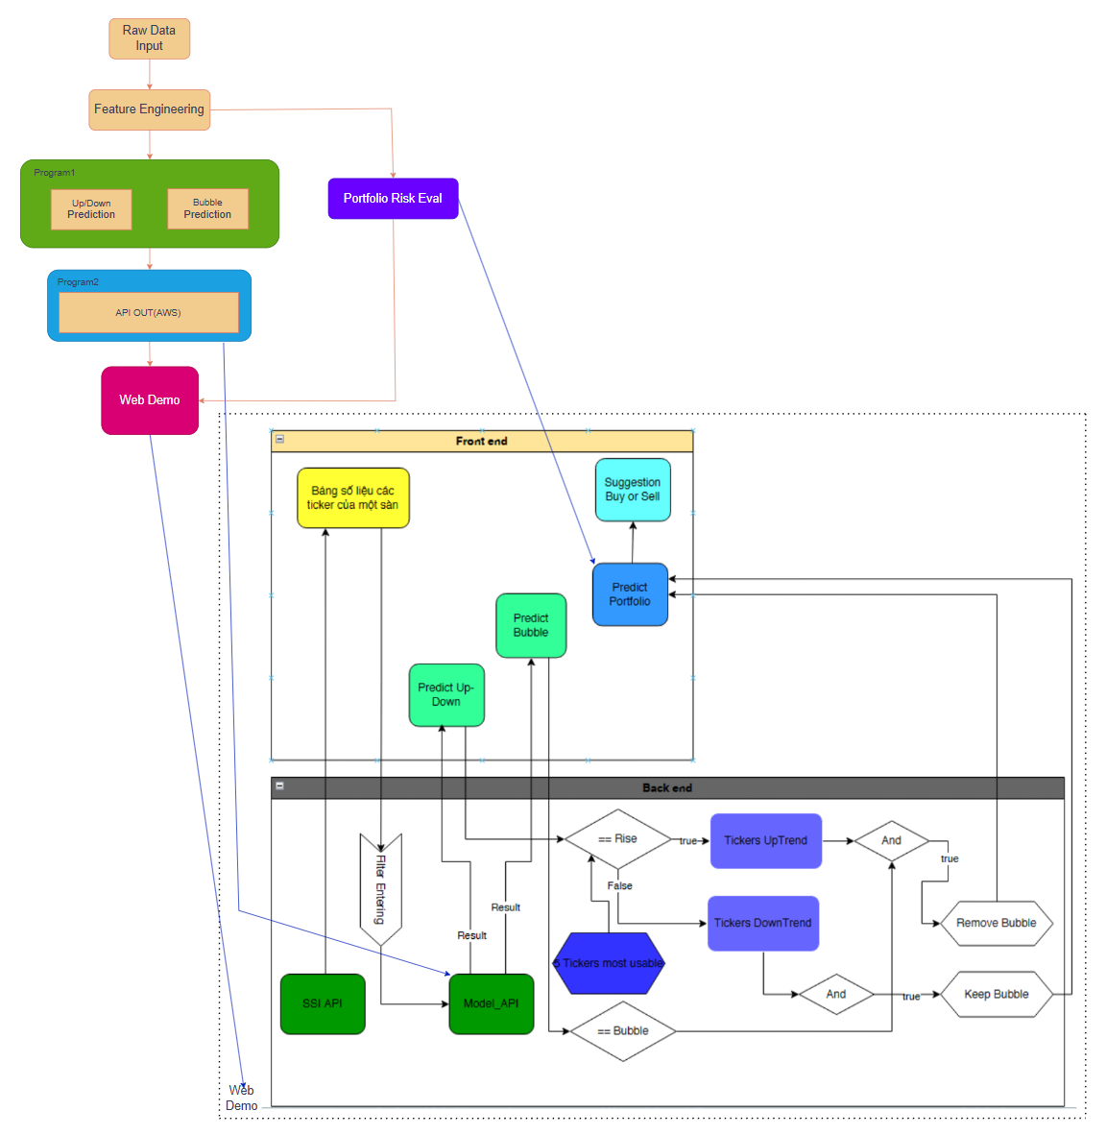
Figure V.1 – Detailed flow of the Web Application integrating Frontend and Backend operations (Source: Own work).

2. Detailed Description

2.1 Data Flow and Model Inference
The overarching system architecture, meticulously detailed in Figure IV.A.4, delineates a robust, end-to-end pipeline designed for comprehensive financial analysis and decision support. The journey commences with Raw Data Input, a critical phase where a vast array of stock market data is systematically collected. This includes not only fundamental metrics like price and trading volume but also a rich set of technical indicators, all primarily sourced through the highly reliable SSI API. This initial data acquisition forms the bedrock for subsequent analytical stages.
Following data ingestion, the system proceeds to the Feature Engineering phase. Here, the raw, unprocessed data undergoes sophisticated transformations to yield meaningful and predictive input features. This involves the derivation of key financial metrics such as returns, volatility, Average True Range (ATR), various moving averages, and refined price momentum indicators. The meticulous engineering of these features is paramount, as their quality directly influences the accuracy and efficacy of downstream predictive models.
The heart of the system resides within the AI Model Layer, which is architecturally designed as a dual-module core prediction engine operating independently yet synergistically. The first module, Up/Down Prediction, is specifically engineered to forecast the weekly trends of stock prices, predicting whether a given stock is poised to rise or fall. Concurrently, the second module, Bubble Detection, employs advanced statistical methodologies to identify monthly stock price bubbles, flagging instances where current valuations significantly deviate from fundamental intrinsic values. This dual-pronged predictive approach provides a comprehensive view of both short-term market dynamics and potential medium-term market inefficiencies.
Subsequent to the core predictive analysis, the system transitions to the Portfolio Risk Evaluation module. This crucial component takes the outputs from the AI models and processes them through a sophisticated financial framework to compute comprehensive portfolio-level risk metrics. Leveraging established multi-factor models such as the Capital Asset Pricing Model (CAPM), Fama-French, and Carhart models, this module meticulously assesses key risk indicators including alpha, beta, and R-squared. This rigorous risk evaluation provides users with a quantitative understanding of their portfolio's exposure and potential returns.
Finally, the meticulously analyzed data and evaluations are served to the user interface via the Web Demo API. This layer, implemented with the high-performance FastAPI framework, ensures seamless and efficient delivery of prediction results and portfolio evaluations to the frontend through a well-defined set of RESTful APIs, enabling real-time access and interaction for end-users.

2.2 Frontend and Backend Integration Flow
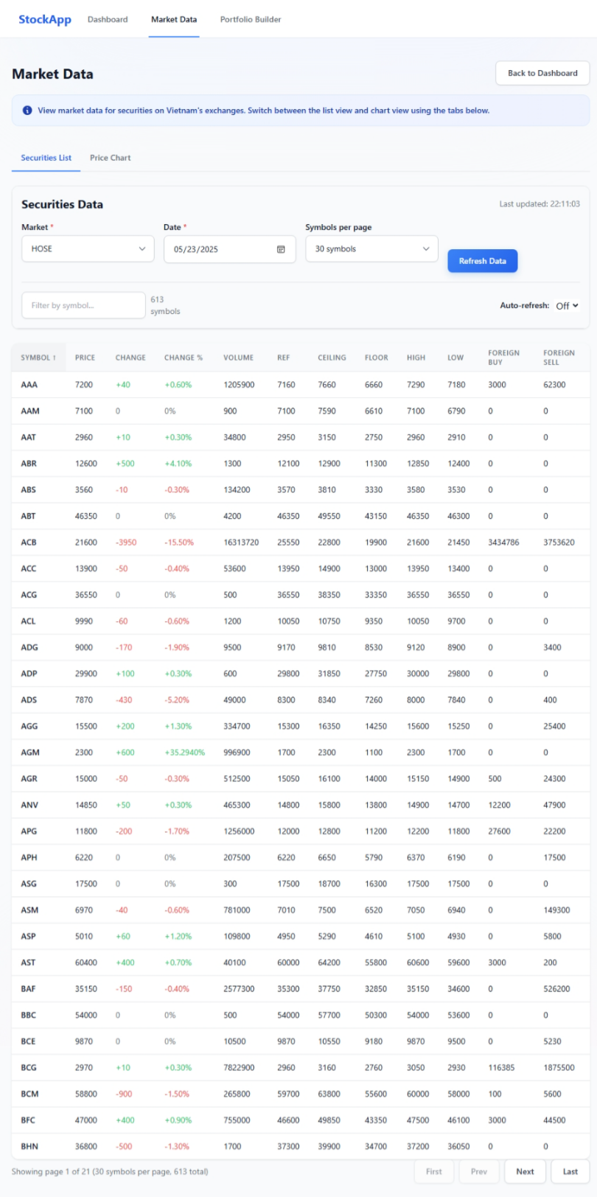
Figure V.2.2.a – Market Data Page on Website (Source: Own work).

Figure V.1 offers a comprehensive insight into the system's operational intricacies, meticulously detailing the integration and flow between its frontend and backend components. The Frontend Components are meticulously designed for intuitive user interaction and clear information display. The primary interface, as depicted in Figure V.2.2.a, presents a dynamic Stock Data Table offering a clear and concise presentation of essential stock information. Users can customize their view by selecting the market exchange (e.g., HOSE), the specific date for data retrieval, and the number of symbols displayed per page, ensuring a tailored data consumption experience. This table dynamically retrieves current prices, trading volumes, and other vital metrics directly from the SSI API.
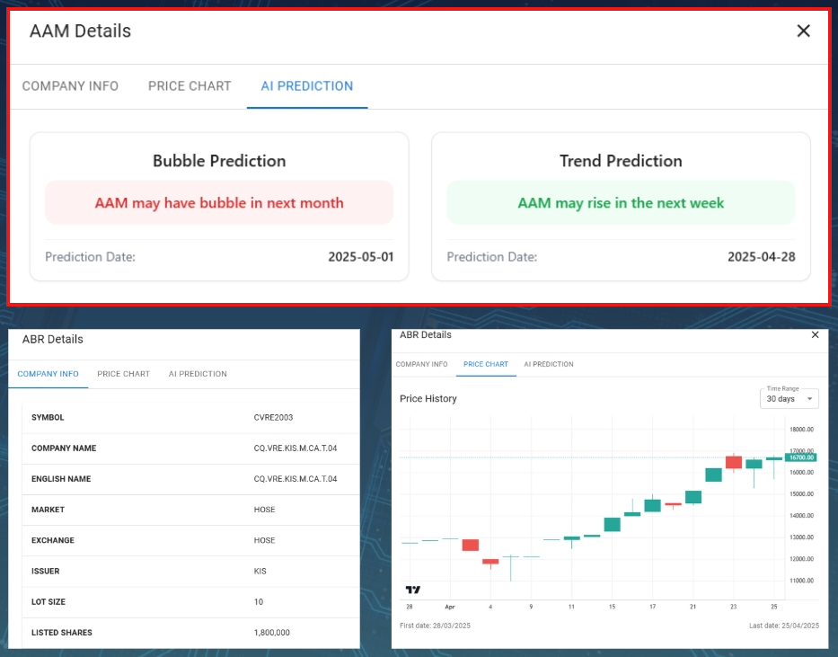
Figure V.2.2.b – Stock Detail popup window (Source: Own work).
Upon clicking a specific stock ticker within the main data table, a detailed modal window appears, as illustrated in Figure V.2.2.b. This modal is segmented into three crucial tabs: "Company Info", "Price Chart", and "AI Prediction". The "Company Info" tab provides fundamental details about the selected company. The "Price Chart" tab visualizes historical price movements through an interactive candlestick chart, allowing users to analyze past performance. Crucially, the "AI Prediction" tab, highlighted in Figure V.2.2.b, empowers users with predictive insights. Here, the system presents both a "Bubble Prediction" for the upcoming month and a "Trend Prediction" (Up/Down) for the next week, offering actionable intelligence for short-term price movements and informed risk management.
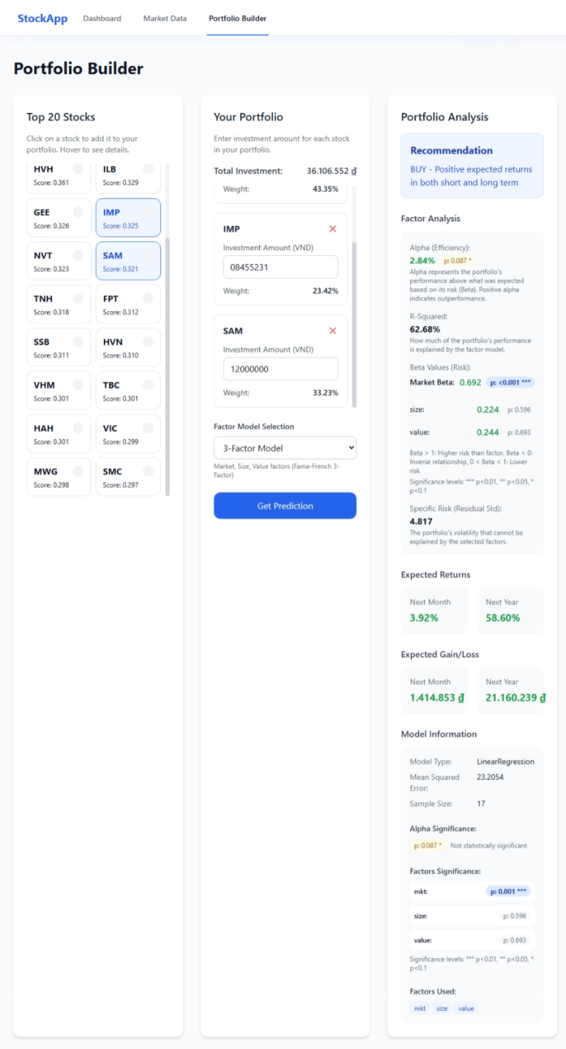
Figure V.2.2.c – Portfolio Builder Page on Website (Source: Own work).
Beyond individual stock analysis, the "Portfolio Builder" component, shown in Figure V.2.2.c, offers a powerful simulation environment. This dedicated page provides users with a curated list of the "Top 20 Stocks," meticulously identified as the most promising based on a multi-factor evaluation including Momentum, Volume Strength, Volatility, Foreign Interest, and Recent Change. Users can select multiple stocks from this list and input their desired investment amounts for each. The system then calculates and displays simulated portfolio returns, meticulously derived from the AI model predictions and a comprehensive multi-factor risk evaluation. The "Portfolio Analysis" section on this page provides a "Recommendation" (e.g., "BUY - Positive expected returns in both short and long term"), along with detailed "Factor Analysis" including Alpha, R-Squared, Market Beta, Value, and Specific Risk. Furthermore, it projects "Expected Returns" and "Expected Gain/Loss" for both the next month and the next year, providing a holistic view of the portfolio's potential performance. Model information, such as Model Type, Mean Squared Error, Sample Size, and the significance of Alpha and other factors, is also presented to ensure transparency and aid user understanding.
The Backend Components serve as the robust engine driving these sophisticated frontend functionalities. The SSI API acts as the primary conduit for fetching real-time market data directly from the stock exchange database, ensuring that all analyses are based on the freshest available information. The Model API is a highly optimized FastAPI service dedicated to serving the AI model predictions for both bubble detection and up/down trends, guaranteeing rapid and reliable inference. Crucially, the Filtering and Decision Logic module acts as an intelligent intermediary. It initially filters and ranks stock tickers based on their predicted trend (UpTrend or DownTrend). Subsequently, it refines these recommendations by evaluating the presence of bubble signals. The logic is clearly defined: if a stock is predicted to rise and shows no signs of a bubble, it is considered for recommendation; if a stock is rising but exhibits a bubble signal, it is flagged for removal to mitigate potential risk; and if a stock is predicted to fall, it is automatically discarded from immediate consideration unless specifically required for broader strategic purposes. Following this meticulous prediction and filtering process, the system identifies and prioritizes the Top 5 and Top 20 Ticker Selection—representing the most viable and usable stocks for investors—which are then prominently displayed on the frontend for immediate consideration within the "Market Data" and "Portfolio Builder" sections, respectively.

3. Technologies Used
From a technological standpoint, the system leverages a robust stack. Backend Technologies prominently feature FastAPI for its high performance in serving model inference and data query endpoints, ensuring swift and efficient data access. On the Frontend, ReactJS is employed for building a responsive and dynamic user interface, providing a seamless and intuitive user experience. Axios facilitates efficient API communication between the frontend and backend, ensuring smooth data exchange. The Model Training Environment is built upon Python 3.9, augmented by a suite of powerful libraries including Scikit-learn, PyTorch, Statsmodels, Optuna, and Pandas, facilitating advanced machine learning model development and optimization.

4. Key Features
The system's Key Features underscore its comprehensive and user-centric design. Dynamic Data Update ensures that all analyses are based on the freshest available information, with data retrieved from the SSI API and MongoDB refreshed periodically every 2 hours. Real-time Interaction empowers users to actively query predictions for specific stock codes or entire portfolios, fostering a dynamic and responsive analytical environment. The system offers Comprehensive Analysis, uniquely combining short-term (trend) and medium-term (bubble) forecasts with long-term (portfolio risk) evaluations, providing a holistic perspective on investment opportunities and risks. Finally, Clear Decision Support is a cornerstone feature, where buy/sell recommendations are not merely provided but are transparently generated based on a synthesis of AI predictions and rigorous multi-factor financial assessments, enabling users to make informed and confident investment decisions.

B. Intelligent Web Platform for Financial Investment Support
To facilitate user engagement in financial investment, a web platform is under development. This platform will feature dynamically updated tabular displays of stock code information, complemented by advanced functionalities. Notably, it will identify and present the top 20 promising stock codes based on a composite analysis of price momentum, trading volume, price volatility, foreign investor activity, and observable OHLC (Open, High, Low, Close) patterns. Furthermore, artificial intelligence (AI) models are integrated to provide insights into potential price bubbles over the subsequent month and prevailing market trends in the coming week. The system will also generate actionable buy/sell recommendations, driven by profit predictions evaluated across various risk-defined portfolios.

1. AI Model Integration
The intelligence of the platform is augmented through the incorporation of AI across three key features: Bubble Prediction, Trend Prediction, and Buy/Sell Recommendations. These integrated AI capabilities aim to provide users with sophisticated analytical support for their investment decisions.

2. Data Flow and Processing
The entire data ecosystem relies on the SSI API for data acquisition, with processing bifurcated into two primary streams. The first stream focuses on the presentation of stock code information. This involves retrieving market-wide stock code details via the https://fc-data.ssi.com.vn/api/v2/Market/Securities endpoint and fetching granular information for individual stock codes, including data necessary for tabular displays, through the https://fc-data.ssi.com.vn/api/v2/Market/DailyStockPrice endpoint. Additionally, OHLC data, crucial for rendering candlestick charts, is obtained from the https://fc data.ssi.com.vn/api/v2/Market/DailyOhlc endpoint.
Table V.2: input data API.
MaCK | Symbol
Ceiling | CeilingPrice
Floor | FloorPrice
TC | RefPrice
Matched Order (Price) | ClosePrice
Matched Order (Volume) | TotalMatchVol
Matched Order (+/-) | PriceChange
Matched Order (+/- %) | PerPriceChange
Total Volume | TotalTradedVol
High | HighestPrice
Low | LowestPrice
Foreign Investors (Buy) | ForeignBuyVolTotal
Foreign Investors (Sell) | ForeignSellVolTotal
Foreign Investors (Room) | ForeignCurrentRoom

The second data processing stream is dedicated to identifying the top 20 potential stock codes within a user-specified market. This involves leveraging the SSI API to extract critical data points such as price change, percentage price change, total matched volume, total traded volume, closing price, high price, low price, total foreign buying volume, and total foreign selling volume. Subsequent analysis involves a multi-faceted approach. Price momentum is assessed by analyzing the sustained positive movement of price change and percentage price change over defined periods (e.g., 5, 10, 30 days) and by comparing stock prices against their 5-day moving average, calculated from the "Daily OHLC" API. Trading volume trends are evaluated by comparing current volume against historical averages derived from the "Daily Stock Price" API. Volatility is quantified by calculating the standard deviation of daily price changes using high, low, and close prices from the "Daily OHLC" API. Foreign investor activity is gauged by calculating the net buying volume from "Daily Stock Price" API data.
To arrive at the top 20 potential stocks, the individual factor indicators are first normalized to a common scale (0-1) using Min-Max Scaling or Z-score Standardization. Subsequently, each factor is assigned a weight based on predefined investment strategies or user risk preferences. A "potential" score is then calculated for each stock by taking a weighted sum of its normalized factor values. Stocks are then ranked based on these potential scores, and the top 20 are selected. Finally, these 20 promising stocks are further categorized based on the AI's predicted trend (upward or downward). These categorized stocks, along with user-specified investment amounts, are then fed into the multi-factor model to project potential earnings over the next month or year, ultimately driving the buy/sell recommendations.

VI. Results and Discussion

1. Results and Analysis
The implementation of Logistic Regression, SVM, LSTM, and Transformer models was successfully completed for two key tasks: Bubble Price Prediction (BB) and Up/Down Prediction(UD)
Key findings include:
- Bubble Prediction (BB): Logistic Regression dominates with 376 high-performing models, followed by LSTM (126 models), Transformer (104 models), and Support Vector Machine (SVM) (92 models).
- Up/Down Trend Prediction (UD):SVM continues to lead with 360 models, ahead of Logistic Regression (102models), LSTM (79 models), and Transformer (173models).
Good model quantity review:
Table VI.1. Good model quantity review.
Model | BB | UD
SVM | 92 | 360
LR | 384 | 102
TFM | 104 | 173
LSTM | 126 | 79
- Evaluation Metrics:
- BB Performance (Test Set):Figure IV.B.3.2.c
Accuracy: Average of 0.57, ranging from 0 to 1.0.
F1-score: Average of 0.53, ranging from 0 to 1.0.
- UD Performance (Test Set):Figure IV.B.3.2.f
Accuracy: Average of 0.54, with a maximum of 0.98.
F1-score: Average of 0.49, with a maximum of 0.99.
- Conclusion:
SVM produces the largest number of strong models.
Model performance is quite dispersed, with a high standard deviation.
- Portfolio Risk Assessment:
Multi-factor models (CAPM, Fama-French 3-Factor, Carhart 4-Factor, and Fama-French 5-Factor) were successfully applied to evaluate portfolio Alpha, Beta, Total Risk, and Idiosyncratic Risk, providing robust investment risk analysis.

2. Discussion
The project successfully addressed the initial research objectives:
- Research Questions:
Machine learning models, particularly LSTM and Transformer, demonstrated superior forecasting capabilities over conventional logistic regression, validating the hypothesis.
- Comparison with Existing Literature:
Compared to traditional financial analysis tools and previous AI-based systems, our approach achieved higher predictive accuracy in the Vietnamese stock market context.
- Challenges and Limitations:
  - Data sparsity and low liquidity in some stocks caused instability in model training.
  - External factors such as macroeconomic news and global events were not incorporated into the models.
- Insights:
Integrating macroeconomic indicators and news-based sentiment could further enhance bubble detection and trend prediction models.

3. Recommendations
Based on the project findings, several recommendations are proposed:
- Expand Data Sources:
Incorporate financial news sentiment analysis and macroeconomic indicators into the prediction models.
- Enhance System Capabilities:
Add real-time news analysis, foreign capital flow tracking, and broader asset classes (ETFs, derivatives).
- Practical Deployment:
Develop a mobile application for personalized stock recommendations and risk analysis.
- Further Research Directions:
Apply reinforcement learning to simulate trading strategies and optimize portfolio management dynamically.

4. Personal Reflections
We greatly improved our abilities to manage real-world projects, apply AI models, and handle massive financial data as a result of this project.
Overcoming obstacles in data processing, model tuning, and cooperative working significantly improved our ability to solve problems.
This experience has given us a strong basis for our future work in data science, finance, and AI development.

VII. Conclusion

1. Summary of Results
This project successfully developed an intelligent stock trading support system based on AI:
- Achieved effective predictions of monthly bubble risks and weekly price trends.
- Performed comprehensive portfolio risk and return assessments using multi-factor financial models.
- Confirmed the superiority of LSTM and Transformer models in volatile financial market prediction tasks.
Summary: All core research objectives were achieved, demonstrating the system’s practical value and academic significance.

2. Contributions and Project Reflections
- Key Contributions:
Pioneered the integration of AI and classical financial models for the Vietnamese stock market context.
Built a scalable and modular system ready for real-world financial applications.
- Reflections:
Project management skills, technical collaboration, and data engineering expertise were significantly improved.
Future projects could benefit from more flexible planning and even tighter quality assurance practices.

3. Limitations and Future Work
Limitations:
- The system relies on historical data and does not factor in real-time macroeconomic shocks.
- Investor sentiment and behavioral factors were not incorporated into the models.
Future Work:
- Integrate real-time news sentiment analysis into bubble prediction modules.
- Apply reinforcement learning for optimizing investment strategies.
- Extend system functionalities into mobile platforms for broader user access.

VIII. Refereences
Bailly, A., Blanc, C., Francis, É., Guillotin, T., Jamal, F., Wakim, B., & Roy, P. (2022).Effects of dataset size and interactions on the prediction performance of logistic regression and deep learning models. Computer Methods and Programs in Biomedicine, 213,106504.
Carhart, M. M. (1997). On persistence in mutual fund performance. The Journal of finance, 52(1), 57-82.
Chen, G., Chen, L., Liu, Y., & Qu, Y. (2021). Stock price bubbles, leverage and systemic risk. International Review of Economics & Finance, 74, 405-417.
Douagi, F. W. B. M., Chaouachi, O., & Sow, M. (2021). The portfolio management: investigation of the Fama-French five-and six-factor asset pricing models. Polish Journal of Management Studies, 23(1), 106-118.
Fama, E. F., & French, K. R. (1993). Common risk factors in the returns on stocks and bonds. Journal of Financial Economics, 33(1), 3-56.
Fama, E. F., & French, K. R. (2015). A five-factor asset pricing model. Journal of Financial Economics, 116(1), 1-22.
Jensen, T. I., Kelly, B., & Pedersen, L. H. (2023). Is there a replication crisis in finance? The Journal of finance, 78(5), 2465-2518.
Khoa, B. T., & Huynh, T. T. (2021). Is it possible to earn abnormal return in an inefficient market? An approach based on machine learning in stock trading. Computational Intelligence and Neuroscience, 2021.
Nassiri, K., & Akhloufi, M. (2023). Transformer models used for text-based question answering systems. Applied Intelligence, 53(9), 10602-10635.
Sharpe, W. F. (1964). Capital asset prices: A theory of market equilibrium under conditions of risk. The Journal of finance, 19(3), 425-442.
Valero-Carreras, D., Alcaraz, J., & Landete, M. (2023). Comparing two SVM models through different metrics based on the confusion matrix. Computers & Operations Research, 152, 106131.
Wen, X., & Li, W. (2023). Time series prediction based on LSTM-attention-LSTM model. IEEE access, 11, 48322-48331.
Sharpe, W. F. (1964). Capital asset prices: A theory of market equilibrium under conditions of risk. The Journal of Finance, 19(3), 425-442.
"William F. Sharpe – Facts". NobelPrize.org. Nobel Prize Outreach AB 2024. Retrieved May 17, 2025 from www.nobelprize.org/prizes/economic-sciences/1990/sharpe/facts/
Fama, E. F., & French, K. R. (1993). Common risk factors in the returns on stocks and bonds. Journal of Financial Economics, 33(1), 3-56.
"Eugene F. Fama – Facts". NobelPrize.org. Nobel Prize Outreach AB 2024. Retrieved May 17, 2025 from https://www.nobelprize.org/prizes/economic-sciences/2013/fama/facts/
Fama, E. F., & French, K. R. (2015). A five-factor asset pricing model. Journal of Financial Economics, 116(1), 1-22.

